***Customizations for salesforce B2C Commerce***

*Storefront Reference Architecture (SFRA)*

1. Google ReCAPTCHA
2. Birthday Offers
3. Coupon Page
4. COD Payment Option

***Google reCAPTCHA for Salesforce B2C Commerce***

Storefront Reference Architecture (SFRA)

**1.** Summary 4

**2.** Component Overview 4

2.1 Introduction 4

2.2 Functional Overview 4

When to use reCAPTCHA Enterprise? 4

How reCAPTCHA Enterprise works? 4

2.3 Type of reCAPTCHA 7

reCAPTCHA v3 7

reCAPTCHA v2 ("I'm not a robot" Checkbox) 8

reCAPTCHA v2 (Invisible reCAPTCHA badge) 8

reCAPTCHA v2 (Android) 8

**3.** Implementation 9

3.1 reCAPTCHA Keys 9

3.1.1 Get Site Key and Secret Key 9

3.2 Store Secret key 11

3.3 Adding the reCAPTCHA widget 11

Automatically render the reCAPTCHA widget 11

3.4 Creating new service 13

3.5 Responses 16

3.6 Error Messages 16

# Summary

Adding Google reCAPTCHA to a salesforce B2C Commerce site’s login page can enhance security and protecting against automated bots attack by verifying the users are not bots.

# Component Overview

## Introduction

Google offers reCAPTCHA (v3 and v2) and reCAPTCHA Enterprise to help to protect the sites from fraudulent activities, spam, and abuse.

With reCAPTCHA Enterprise, you can protect your websites or mobile applications from spam and abuse, and detect other types of fraudulent activities on the sites, such as credential stuffing, account takeover (ATO), and automated account creation. reCAPTCHA Enterprise offers enhanced detection with more granular scores, reason codes for risky events, mobile app SDKs, password breach/leak detection, multi-factor authentication (MFA), and the ability to tune the site-specific model to protect enterprise businesses.

## Functional Overview

## When to use reCAPTCHA Enterprise?

reCAPTCHA Enterprise is useful when you want to protect your websites or mobile applications from bots, and abusive and fraudulent behaviour that are either carried out through automated attacks or done by humans.

## How reCAPTCHA Enterprise works?

When reCAPTCHA Enterprise is deployed in the customer's environment, it interacts with the customer's backend and customer's client (web pages or mobile applications).

When an end user visits a web page or uses a mobile application, the following events are triggered in a sequence:

1. The client loads the web page from the customer backend or launches the mobile application.
2. When the end user triggers an action protected by reCAPTCHA Enterprise such as login, the reCAPTCHA Enterprise JavaScript API or the mobile SDK in the client collects and sends signals to reCAPTCHA Enterprise for analysis.
3. reCAPTCHA Enterprise returns an encrypted reCAPTCHA token to the client for later use.
4. The client sends the encrypted reCAPTCHA token to the customer backend for assessment.
5. The customer backend sends the create assessment (assessments. Create) request and the encrypted reCAPTCHA token to reCAPTCHA Enterprise.
6. After assessing, reCAPTCHA Enterprise returns a verdict (scores from 0.0 through 1.0 and reason code) based on the risk evaluated for this request, to the customer backend.
7. Depending on the verdict, you (as the developer) can determine the next steps to take for that specific user request or action.

The following sequence diagram shows the graphical representation of the reCAPTCHA Enterprise workflow:

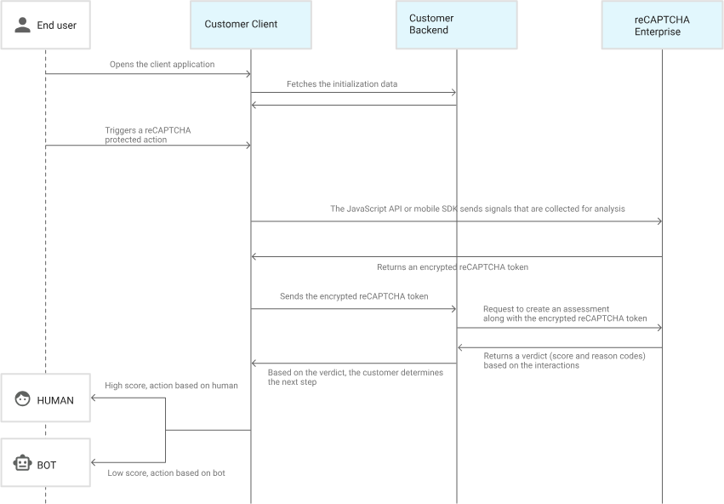

To start using reCAPTCHA, need to sign up for an API key for your site. The key pair consists of a site key and secret key. The site key is used to invoke reCAPTCHA service on your site or mobile application. The secret key authorizes communication between your application backend and the reCAPTCHA server to verify the user’s response. The secret key needs to be kept safe for security purposes.

First, choose the type of reCAPTCHA and then fill in authorized domains or [package names.](https://developer.android.com/guide/topics/manifest/manifest-element.html#package) After you have accepted the terms of service, click Register to get new API key pair.

Now, perform the following steps to add reCAPTCHA to your site or mobile application:

1. Choose the client-side integration:
   * reCAPTCHA v3
   * reCAPTCHA v2
     + Checkbox
     + Invisible
     + Android
2. Verify the User’s response.

## Type of reCAPTCHA

Choosing the type of reCAPTCHA There are four types of reCAPTCHA to choose from when creating a new site.

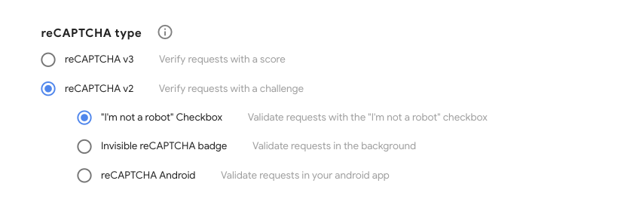

## reCAPTCHA v3

reCAPTCHA v3 allows you to verify if an interaction is legitimate without any user interaction. It is a pure JavaScript API returning a score, giving you the ability to take action in the context of your site: for instance, requiring additional factors of authentication, sending a post to moderation, or throttling bots that may be scraping content.

## reCAPTCHA v2 ("I'm not a robot" Checkbox)

The "I'm not a robot" Checkbox requires the user to click a checkbox indicating the user is not a robot. This will either pass the user immediately (with No CAPTCHA) or challenge them to validate whether or not they are human. This is the simplest option to integrate with and only requires two lines of HTML to render the checkbox.



## reCAPTCHA v2 (Invisible reCAPTCHA badge)

The invisible reCAPTCHA badge does not require the user to click on a checkbox, instead it is invoked directly when the user clicks on an existing button on your site or can be invoked via a JavaScript API call. The integration requires a JavaScript callback when reCAPTCHA verification is complete. By default, only the most suspicious traffic will be prompted to solve a captcha. To alter this behaviour, edit your site security preference under advanced settings.

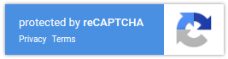

## reCAPTCHA v2 (Android)

The reCAPTCHA Android library is part of the Google play services safety Net APIs. This library provides native Android APIs that you can integrate directly into an app. You should set up Google play services in your app and connect to the GoogleApiClient before invoking the reCAPTCHA API. This will either pass the user through immediately (without a CAPTCHA prompt) or challenge them to validate whether they are human.

# Implementation

## 3.1 reCAPTCHA Keys

A reCAPTCHA key is a unique alphanumeric string of 40 characters that needs to be installed on web pages, in mobile applications, or at the WAF layer to integrate reCAPTCHA Enterprise.

A reCAPTCHA key returns a score for each request, which is based on the user interactions with your site or application. By interpreting these scores, you can take appropriate actions for your site or application, such as allowing or blocking users.

Example reCAPTCHA key: 6Lcm3XXXXXXXXXXXXXXXXXXXXXXXXXXXXXXX5mfX

reCAPTCHA keys can have one of the following integration types:

* SCORE: Returns risk scores. It doesn't display the I'm not a robot checkbox and never shows CAPTCHA challenges.
* CHECKBOX: Displays the I'm not a robot checkbox and might show CAPTCHA challenges after the checkbox is checked.
* INVISIBLE: Doesn't display the I'm not a robot checkbox, but might show CAPTCHA challenges after risk analysis.

### Get Site Key and Secret Key

First need to create account in the google reCAPTCHA. Go to the reCAPTCHA Admin Console and enter your Experience Cloud site’s information. Generate a site key and secret key to create your customized reCAPTCHA authentication.

1. Go to <https://www.google.com/recaptcha>.
2. Click **Admin Console**.
3. Enter a label for your ReCAPTCHA and select the V2 checkbox. 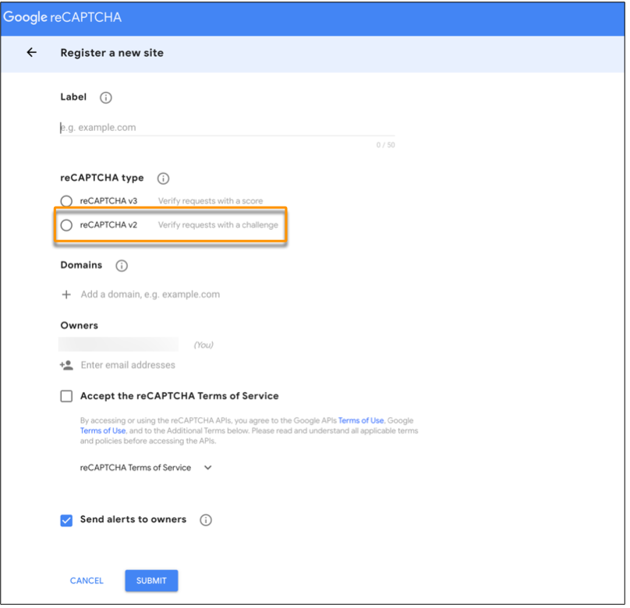
4. Add the URL for your site in the **Domain** section.
5. Accept the terms of service and click **Submit**. Copy the Site Key and Secret Key that Google generates.

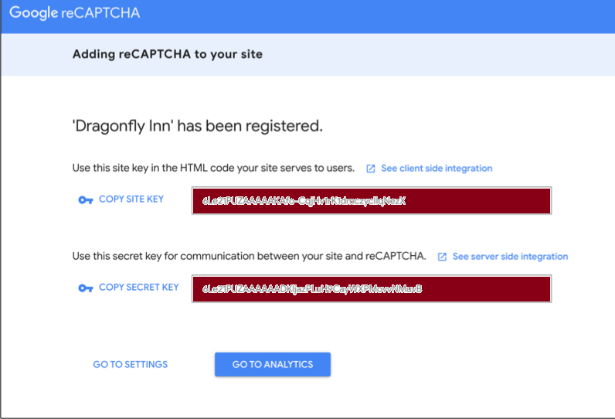

## Store Secret key

Create a new custom preference group and store the secret key.

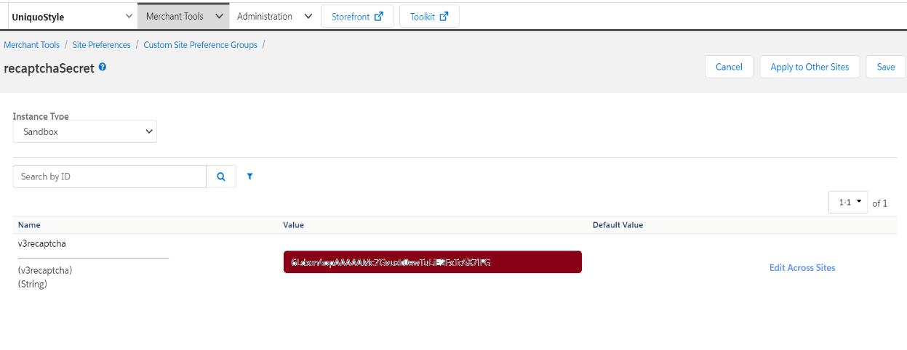

## Adding the reCAPTCHA widget

In this we selected the reCAPTCHA V2 – checkbox type so first needs to add the checkbox in the Login form for that.

To display the widget, you can either:

* Automatically render the reCAPTCHA widget or
* Explicitly render the widget

## Automatically render the reCAPTCHA widget

The easiest method for rendering the reCAPTCHA widget on your page is to include the necessary JavaScript resource and a g-reCAPTCHA tag. The g-reCAPTCHA tag is a DIV element with class name g-reCAPTCHA and your site key in the data-site key attribute:

<html>  
  <head>  
    <title>reCAPTCHA demo: Simple page</title>  
    <script src="https://www.google.com/recaptcha/api.js" async defer></script>  
  </head>  
  <body>  
    <form action="?" method="POST">  
      <div class="g-recaptcha" data-sitekey="your_site_key"></div>  
      <br/>  
      <input type="submit" value="Submit">  
    </form>  
  </body>  
</html>

This type of code to inserted in our file to add the widget for the login form.

In static folder à js folder à recaptcha.js file in that add the below code.

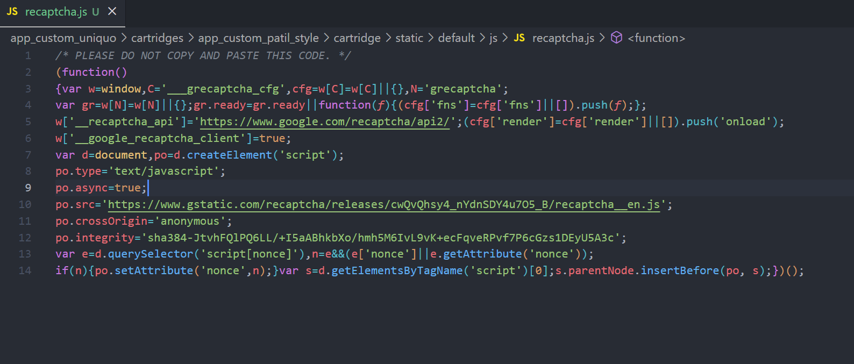

Then In the template à default à account à components à loginForm.isml add the script folder link and add the div class.

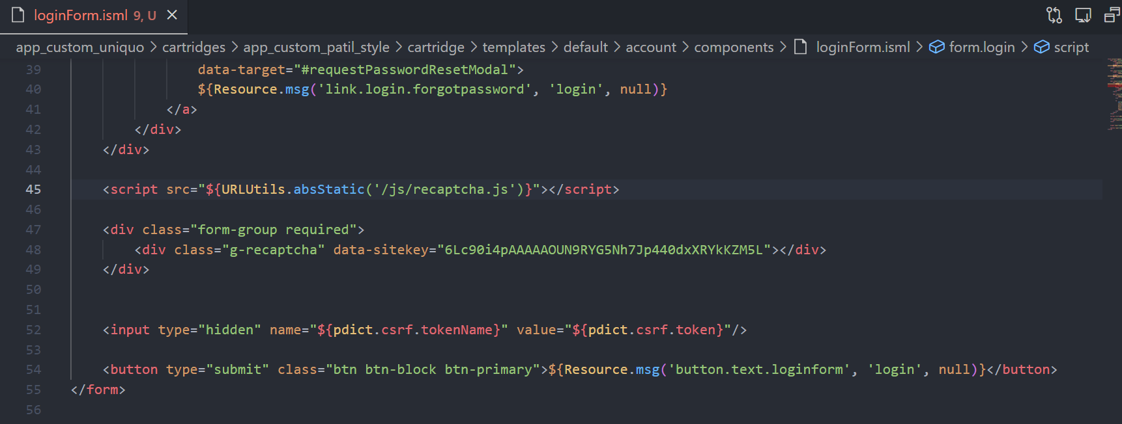

Adding the div tag with class “g-recaptcha” and mentioning the sitekey in the data-sitekey field.

After adding this code, now the form contains the reCAPTCHA widget as shown below.

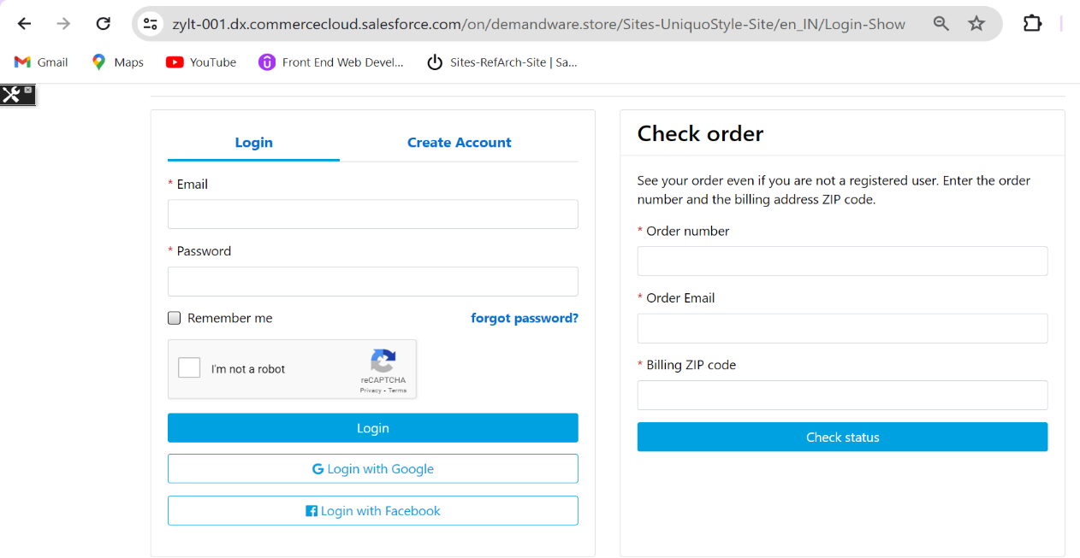

## Creating new service

To call the google reCAPTCHA Api need to create a new service in the Business Manager.

The HTTP type of service is created.

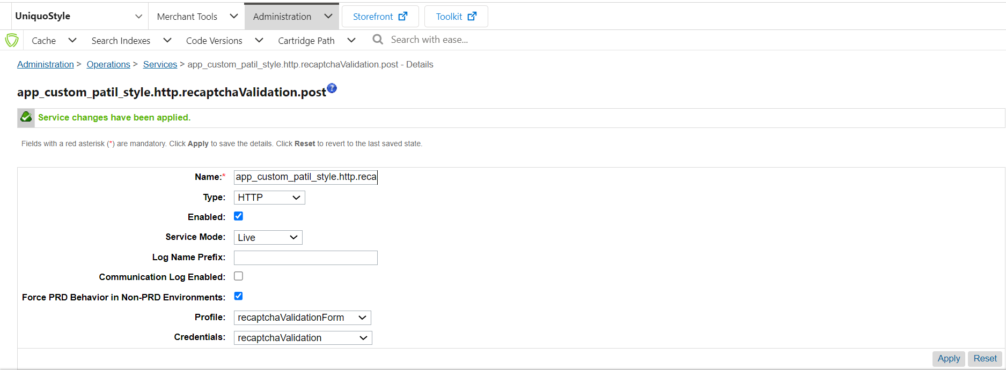

Creating a new profile and credentials for a service.

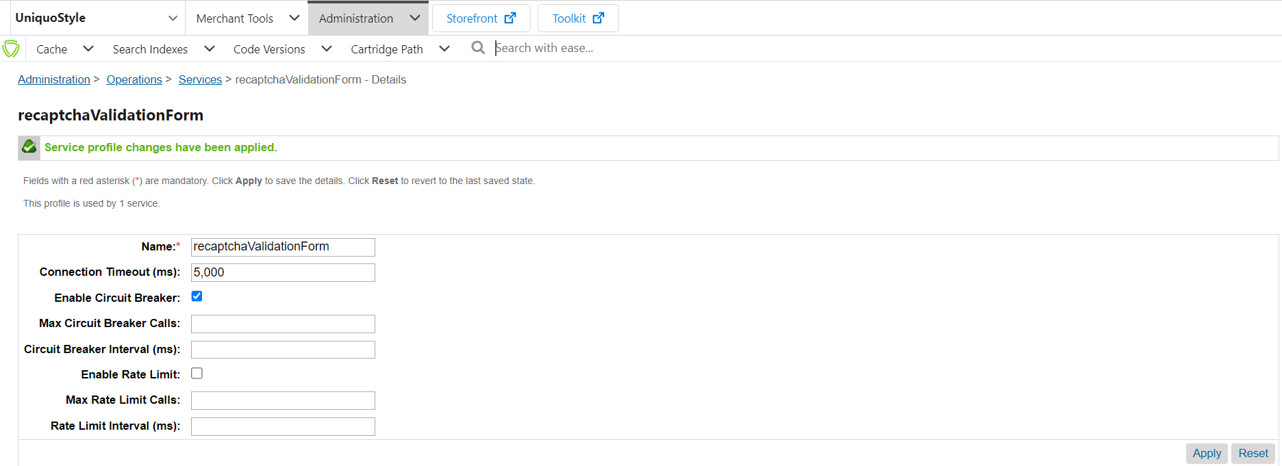

In credentials need to add the URL of reCAPTCHA site verify.

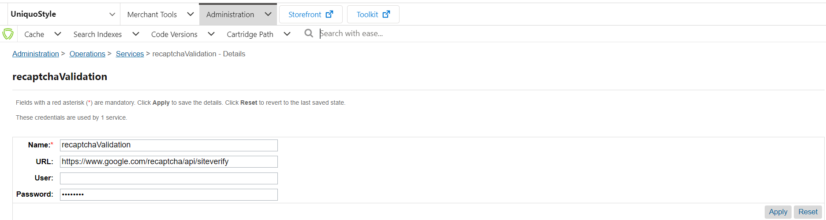

Reading the response from the loginForm.isml in the controller Account.js of route Login and calling the recaptcaResponseValidation function from accountHelpers file.

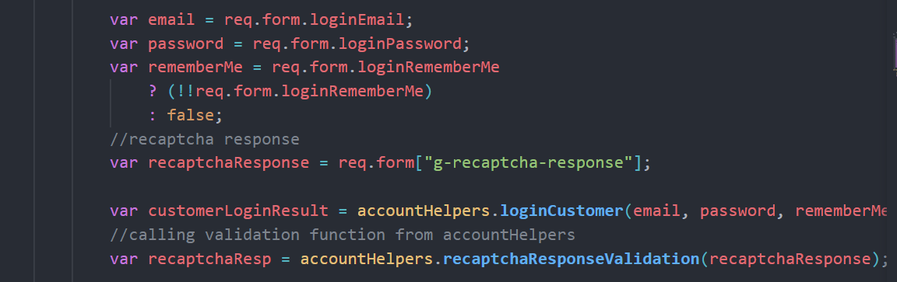

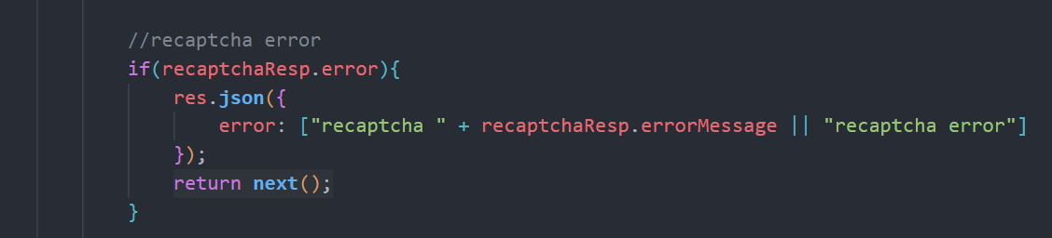

In recaptcaResponseValidation function from accountHelpers file creating the service and getting the response from the google reCAPTCHA by adding the secret key and reCAPTCHA response.

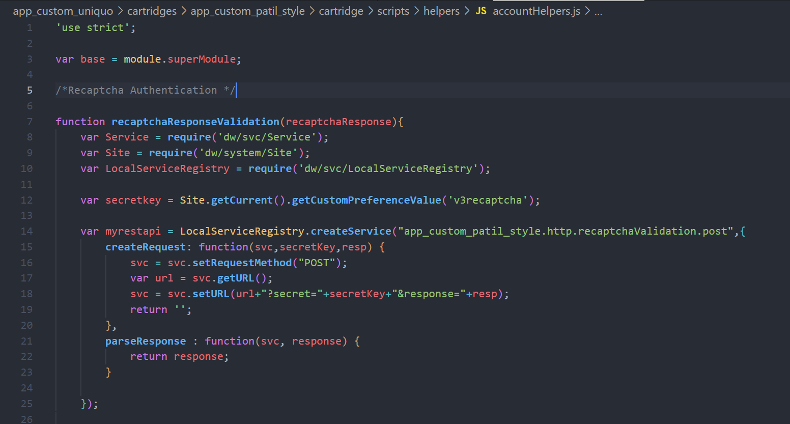

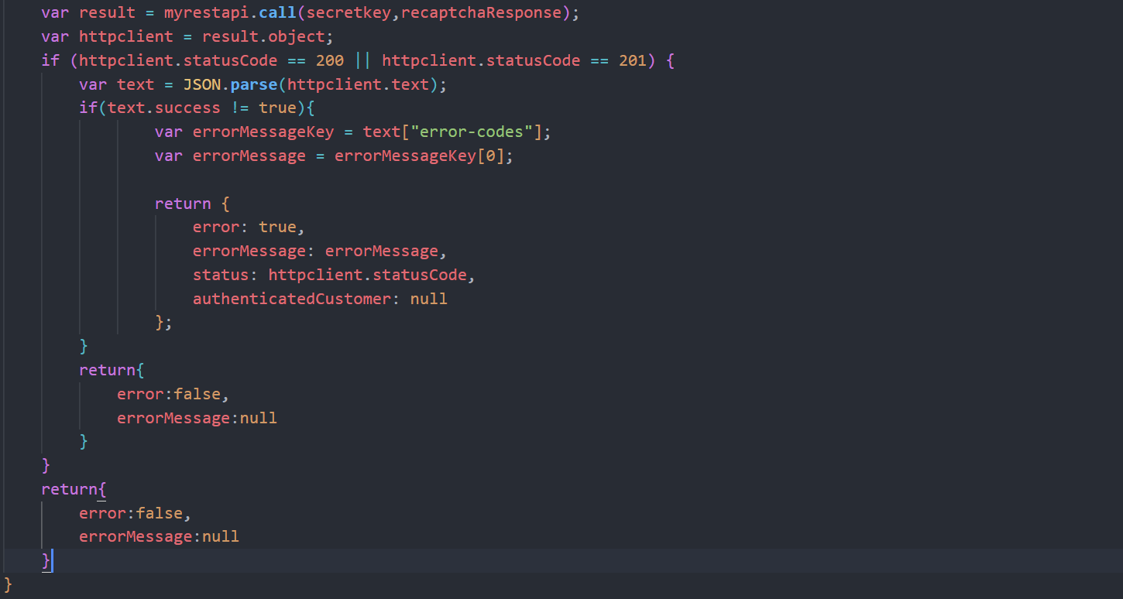

## Responses

Once the user after checking the reCAPTCHA box and by clicking on Login. It is going to redirect to the Account-Show controller.

And the all the Requests passed and failed, Average Score, Session completed, Average response time data is displayed in google reCAPTCHA site of our account.

It will show the data from past 90 days also.

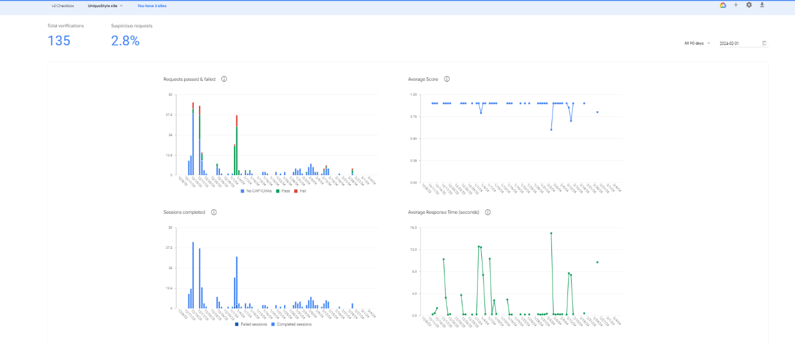

## Error Messages

If any error occurred like the user not checked the checkbox or the timeout has been exceeded then those accurate error messages is going to display as shown below.

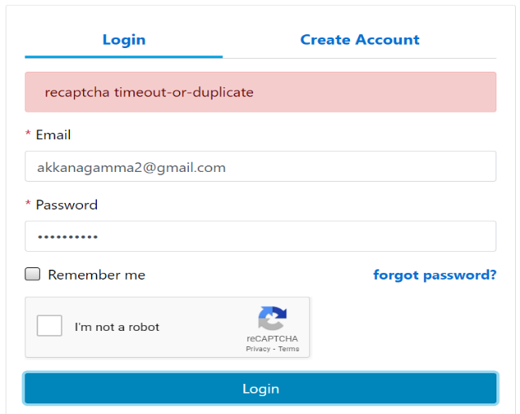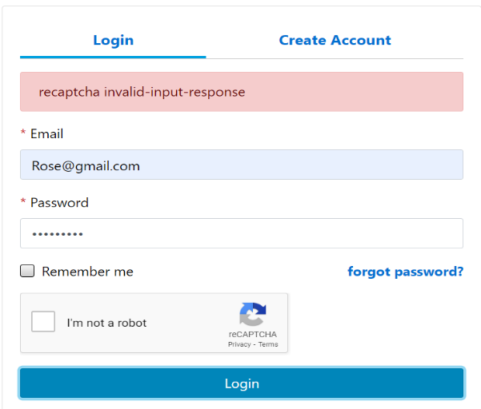

***Birthday Offers for Salesforce B2C Commerce***

Storefront Reference Architecture (SFRA)

1. Summary 19

2. Implementation 19

2.1 Creating New Field 19

2.2 Reading the value from field 20

2.3 Customer Information 21

2.4 Edit the Profile 22

2.5 Save the Profile 24

2.6 Account Show 24

3. Promotion & Campaign 25

3.1 Customer Group 25

3.2 Category 26

3.3 Promotion & Campaign 27

# Summary

Birthday Offers

* Adding the new field in the Login Page to enter the DOB of the user.
* Before one week of the Birthday, the birthday promotion is applicable for the customer.
* Once the Birthday date completes the promotion is not applicable.

# Implementation

## 2.1 Creating New Field

Firstly, adding the new field in the profile.xml file.

In the group of customer adding the field with formid ‘dob’.

Keeping the mandatory value as ‘true’ and min and max date is mentioned for the field.

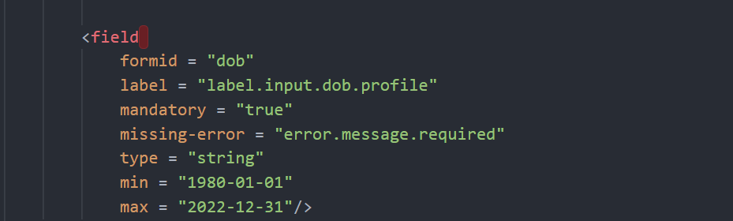

To show the field in the Create Account tab needs to add the div class.

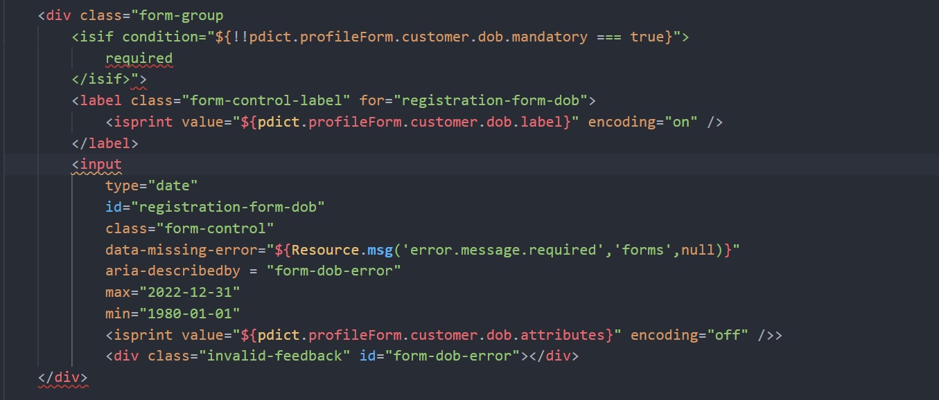

After adding the code in the isml file it will implement in the Create Account tab as shown below.

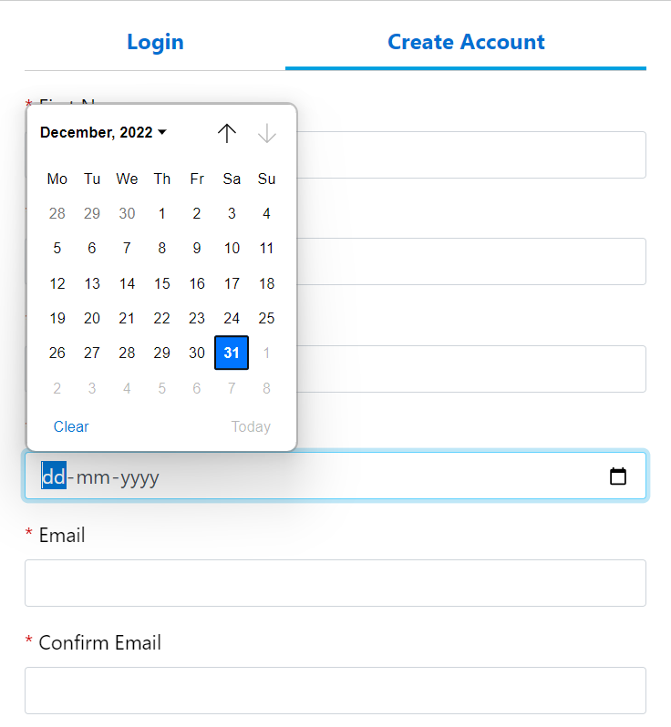

## 2.2 Reading the value from field

In Account-Submit Registration reading the values from the xml file and validating.

Setting the variable for the registrationFormObj as shown below.

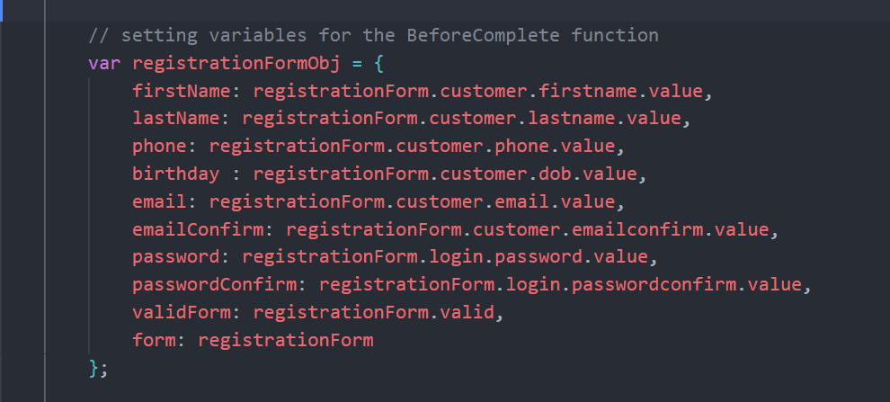

To store the dob value in the database within transaction.wrap function assigning the value to the profile.

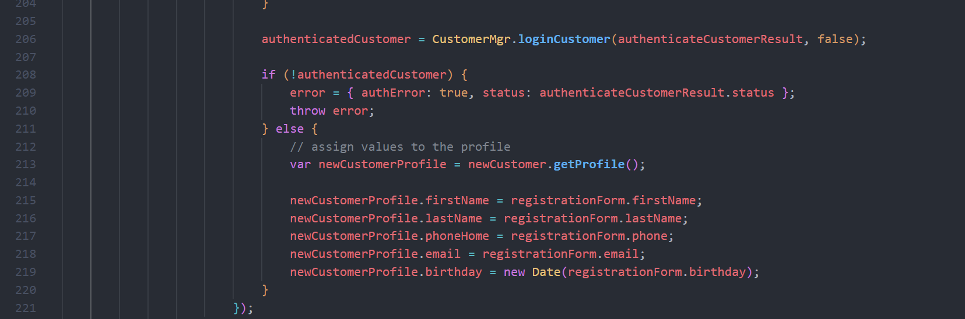

## 2.3 Customer Information

In Account.js file from models folder from getProfile function reading the current customer information from the database.

The value is stored in the date format and converting into the string value by using Stringutils class and calendar.

var StringUtils = **require**('dw/util/StringUtils');

var Calendar = **require**('dw/util/Calendar');

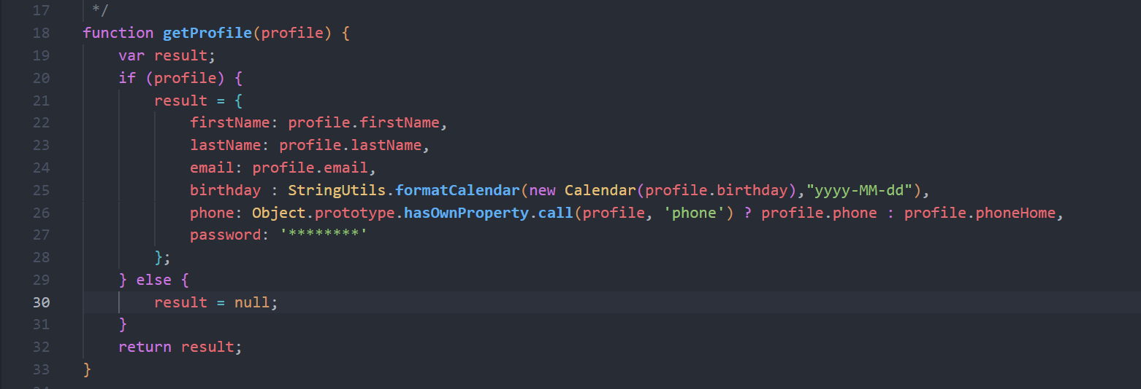

## 2.4 Edit the Profile

Account-EditProfile endpoint renders the page that allows a shopper to edit their profile. The edit profile form is prefilled with the shopper’s first Name, last Name, Phone Number and email.

For this page the new field needs to be added to show the dob in the editProfileForm.isml.

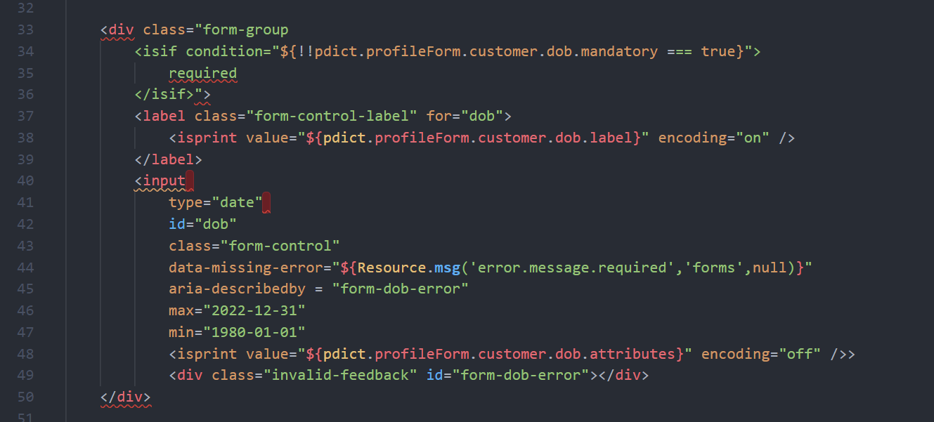

Already from the database we are reading the values of the customer data so it will be shown in the editProfileForm as shown below.

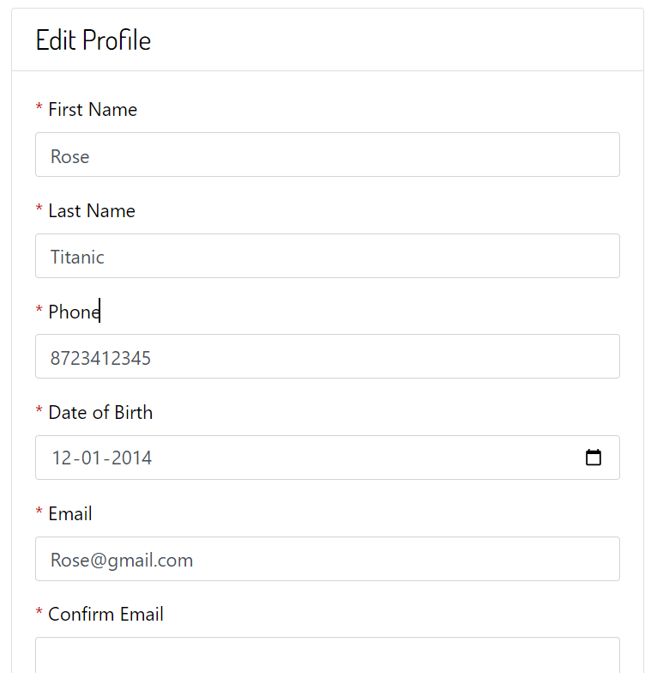

If user wants to change the dob can be done and the data will be updated in the BM.

The below image shows the code of route EditProfile from Account.js file.

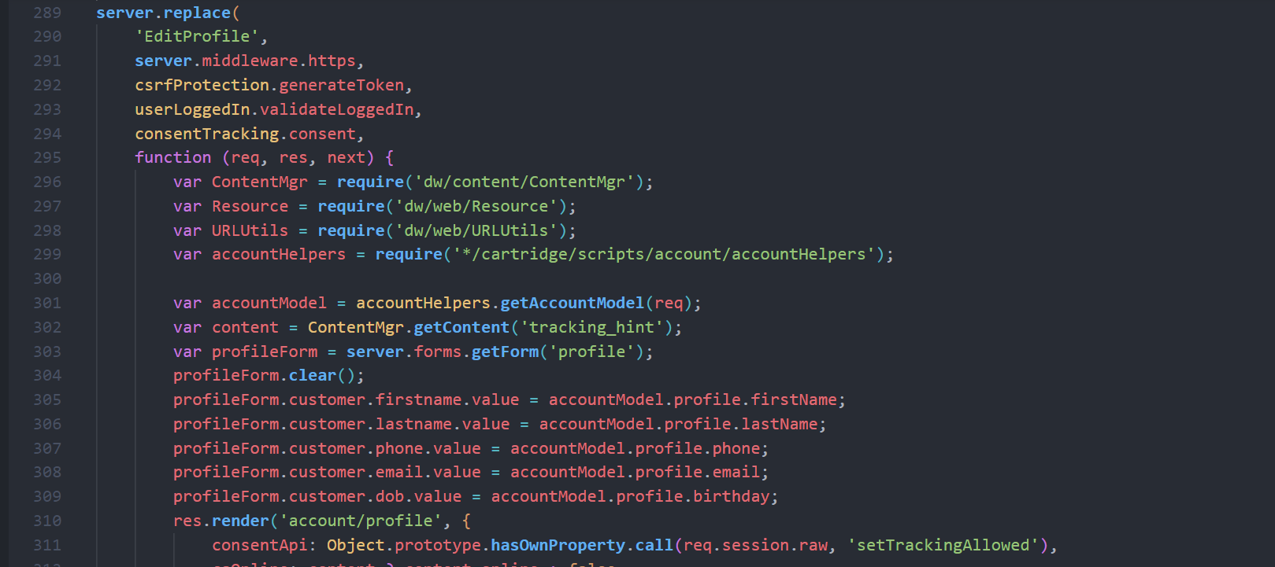

## 2.5 Save the Profile

After the user edit the dob field or any other field its invoking the SaveProfile route to save the edited data to BM.

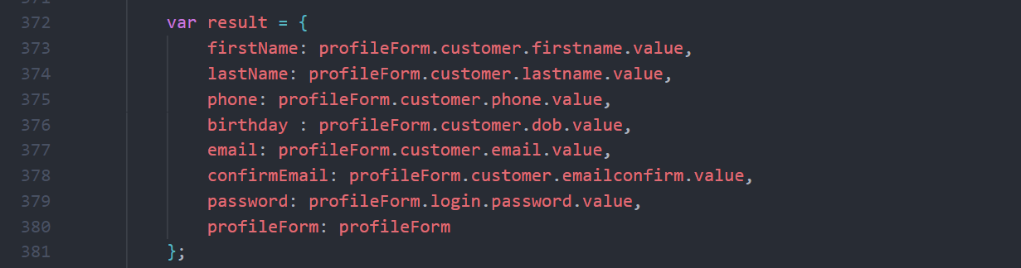

To save back to the BM within Transaction.wrap function.

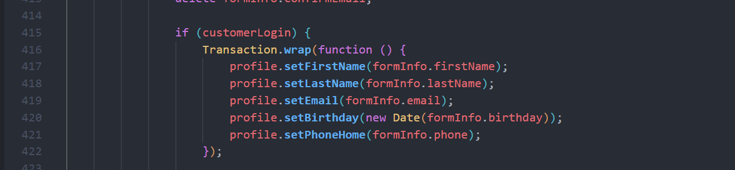

## 2.6 Account Show

The Account-Show endpoint will render the shopper's account page. Once a shopper logs in they will see is a dashboard that displays profile, address, payment and order information.

In the profile tab, the customer data is going to display like First Name, Last Name, Email, Date of Birth and Phone Number.

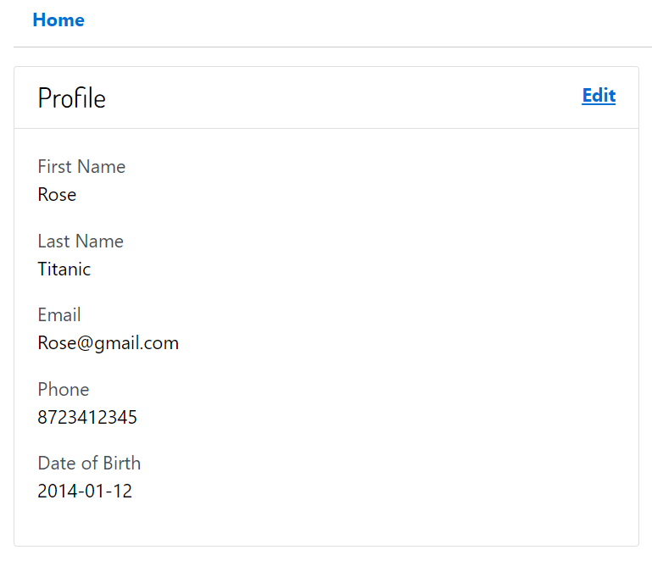

# Promotion & Campaign

## 3.1 Customer Group

Creating a new customer group to add the customers whose birthday is there within one week.

For this customer group the promotion is applied.

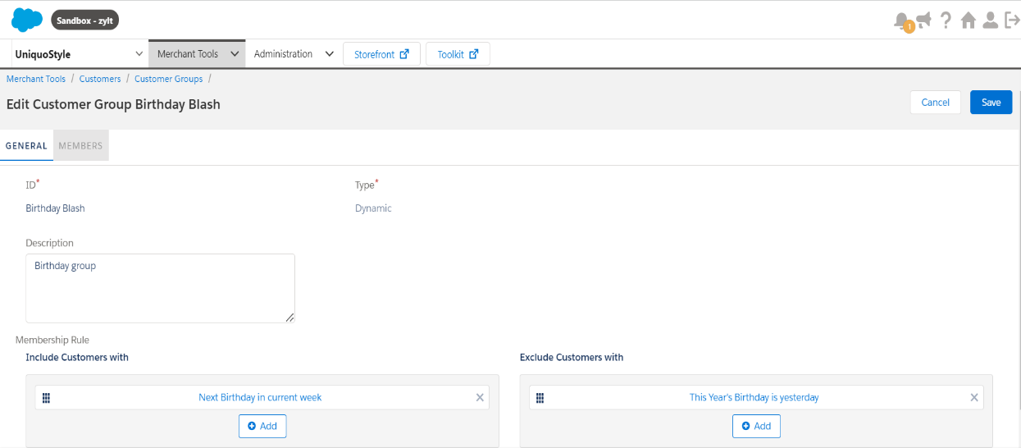

This customer group include the users whose next birthday in current week, and exclude the users whose birthday is yesterday.

## 3.2 Category

Creating a new category to show the products which have discounts for the user who belongs to the customer group called Birthday Blash.

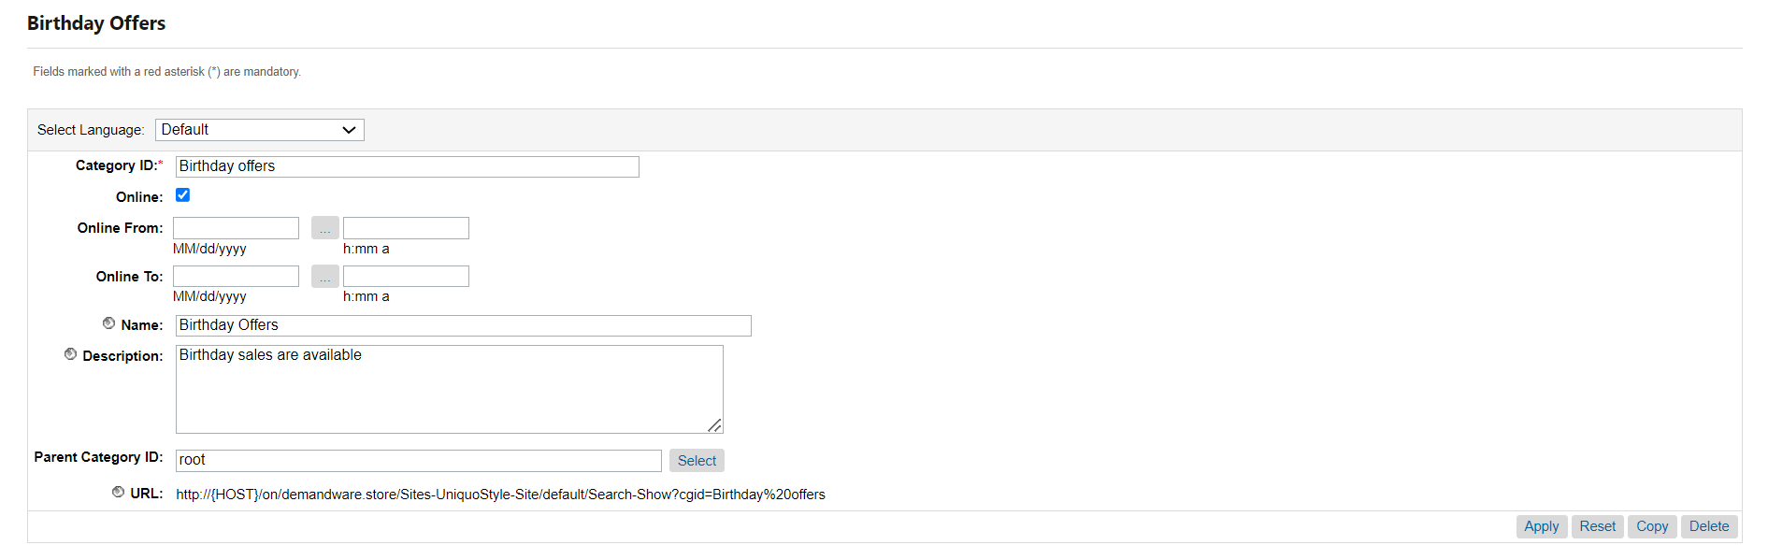

The Birthday Offer is the category which use the categorization rule to display the products. If the product birthday sale custom attribute is set to true.

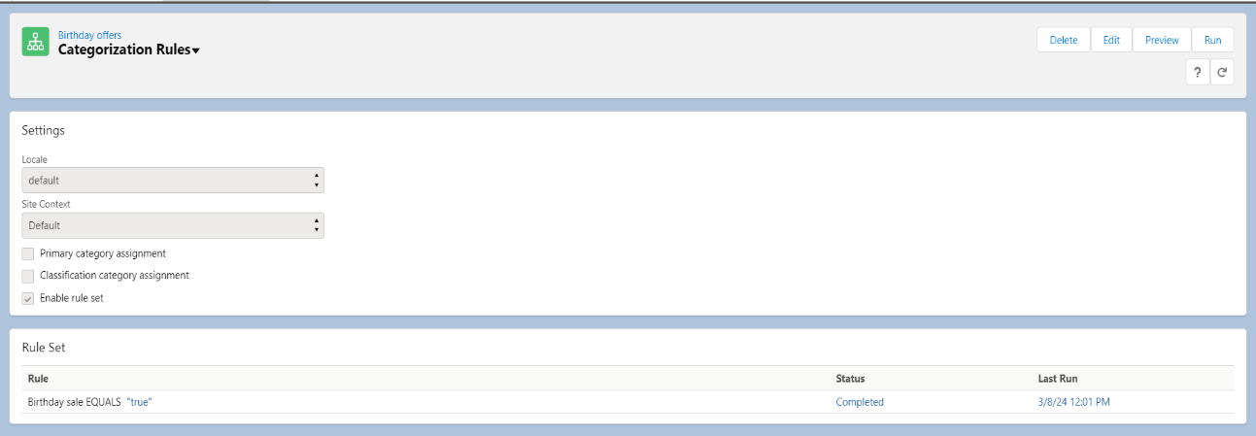

In the product system object adding the new custom attribute for the Birthday sale which is Boolean type. If that product wants to add to the birthday bash category, then the value will be seted as true.

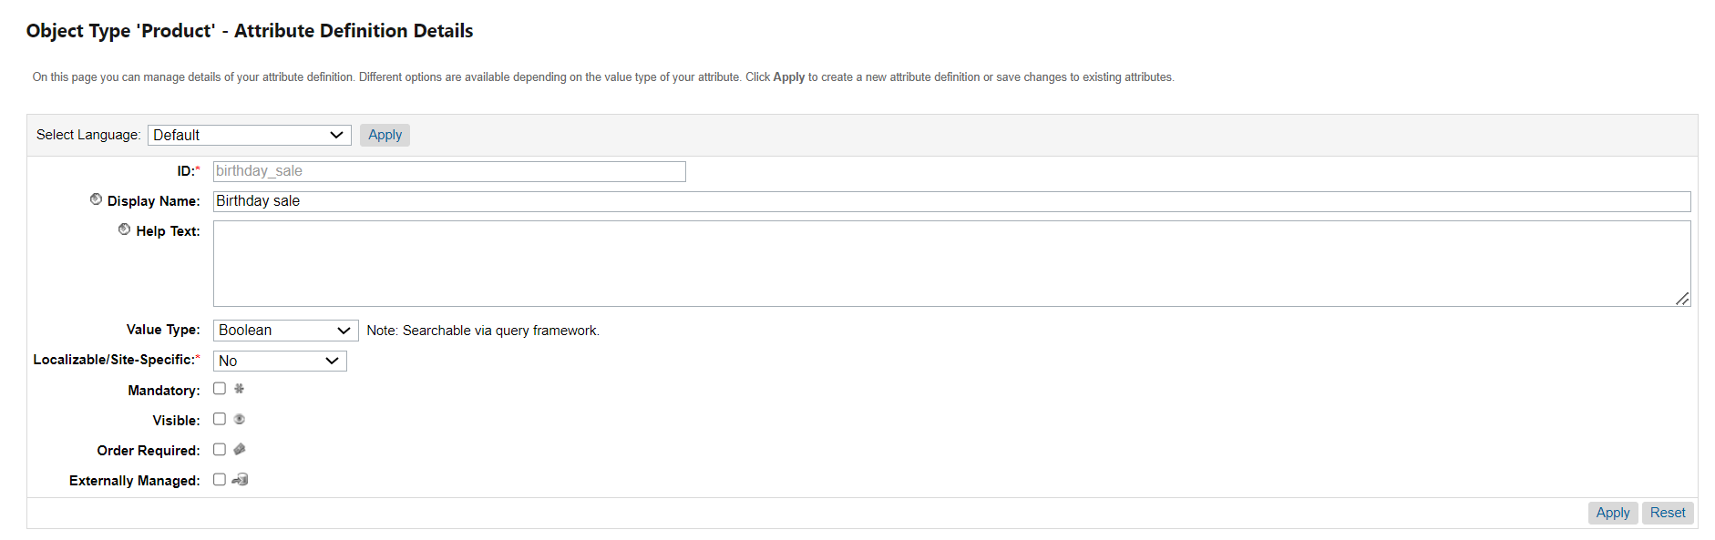

## 3.3 Promotion & Campaign

To provide a discount for the products which are there in the Birthday Offers the promotion is created as shown below.

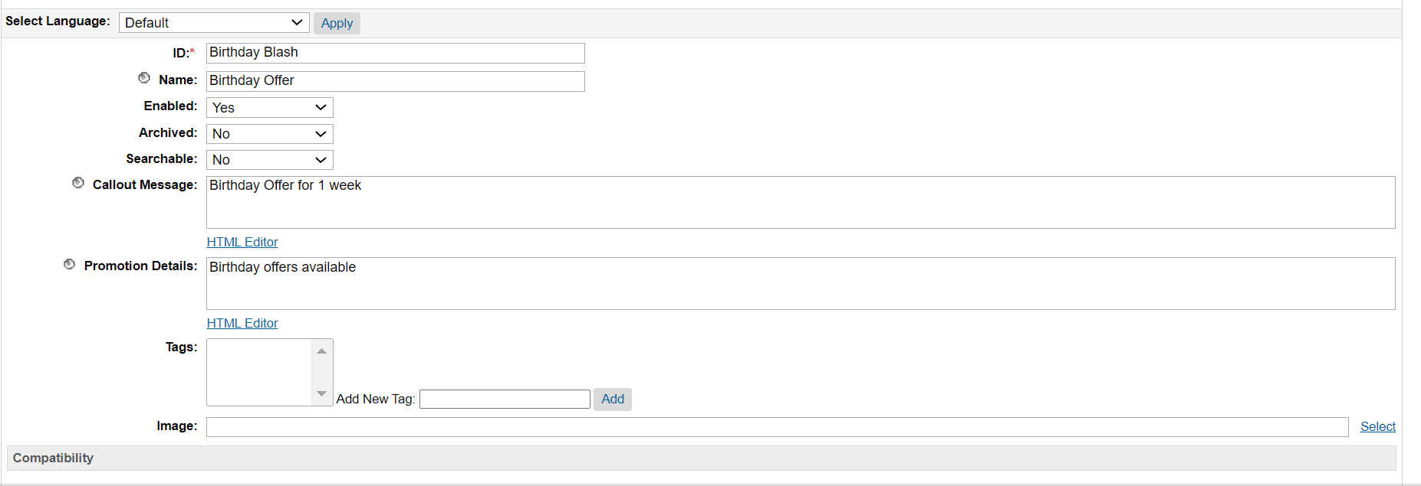

Promotion Rule:

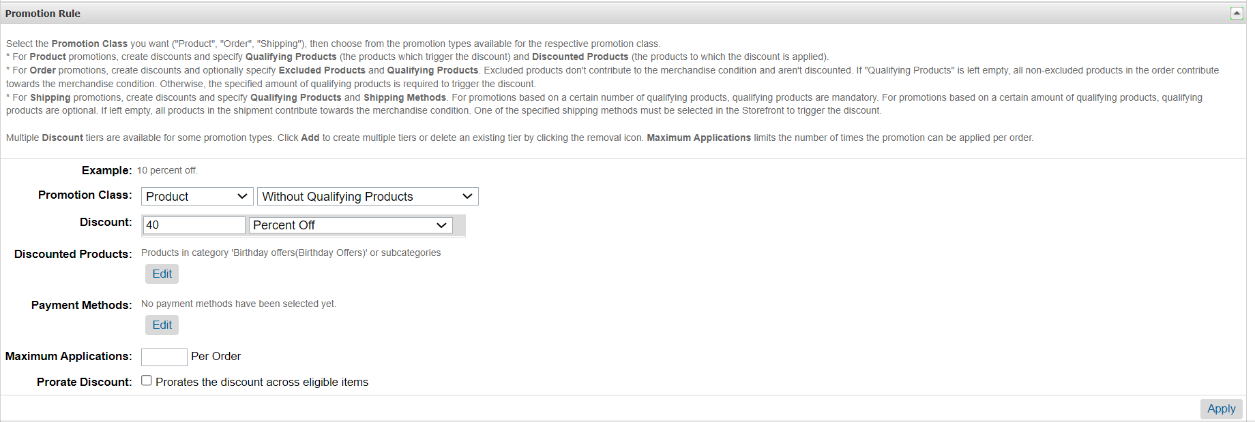

Now creating a campaign to assign this promotion only the Birthday Blash customer group.

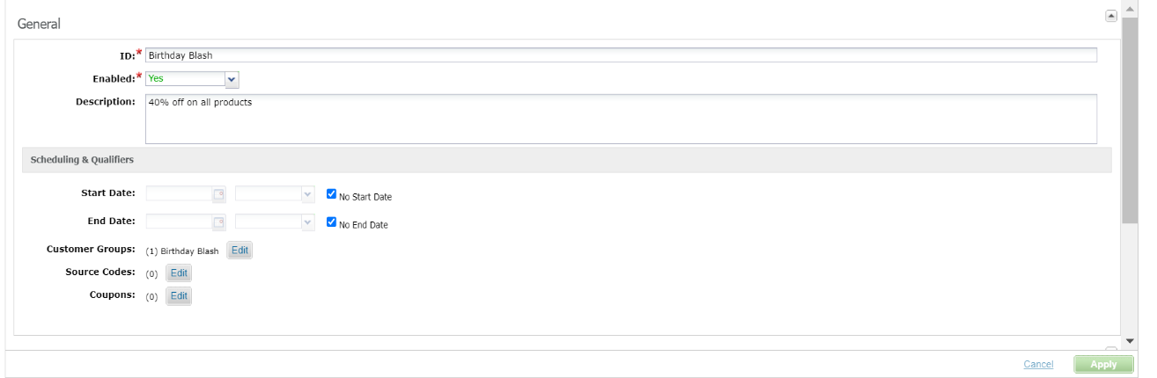

And assign a promotion ‘Birthday Offer’ to this campaign.

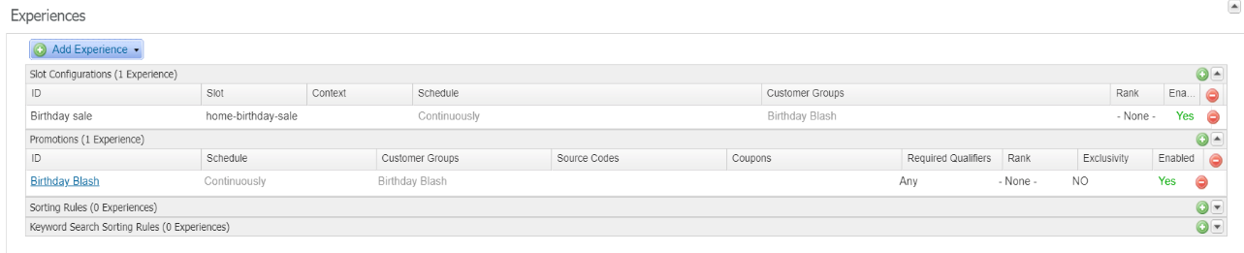

Creating a new content slot to show the content asset in the Home-Page and assigning the campaign to this content slot.

Creating a content slot in the homepage.isml

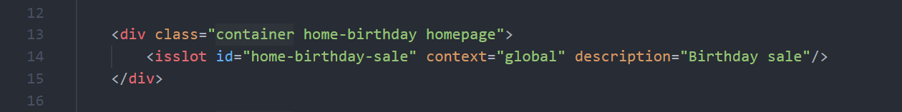

Slot configuration

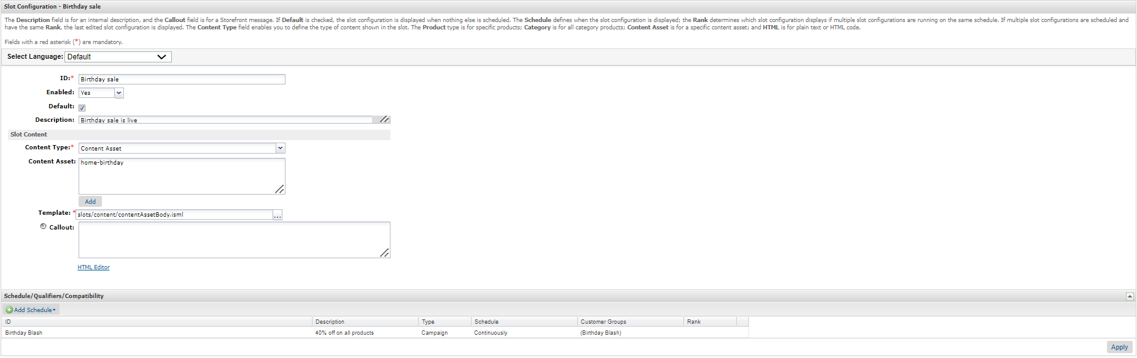

The result of the content Slot

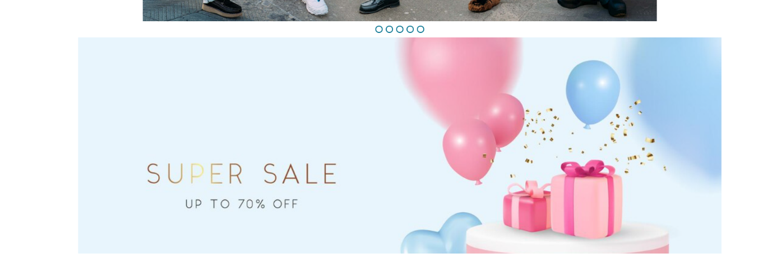

***Coupons Page for Salesforce B2C Commerce***

Storefront Reference Architecture (SFRA)

1. Summary 31

2. Implementation 31

2.1 Script Files 31

2.1.1 Access Token 31

2.1.2 Coupon Code Service 33

2.2 Controller 36

2.3 ISML Template 37

3. Page Accessible 38

4. Result 39

4.1 Guest user 39

4.2 Registered User 40

# Summary

This coupon page helps to show the coupons which are available and applicable for the user.

# Implementation

New controller and route is need to be created for the coupons page.

## Script Files

The two more scripts files are added to call the services and to validate the coupon details.

The two service are created one for the authorization token and one for the coupon code values.

### 2.1.1 Access Token

The first service authorization token:

Service:

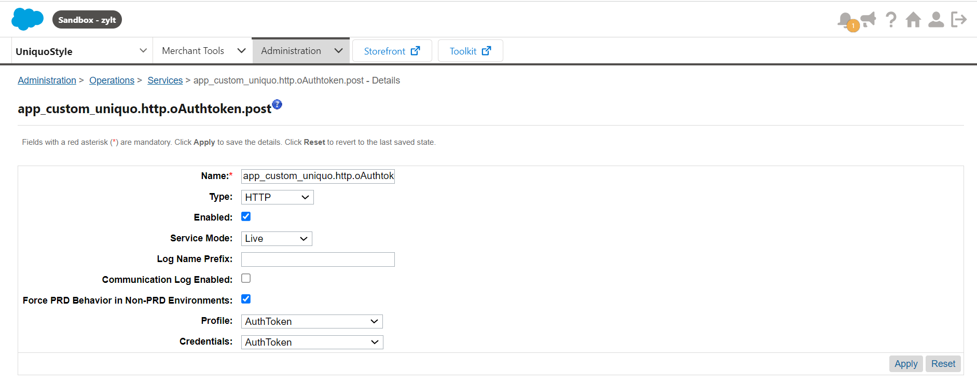

Profile:

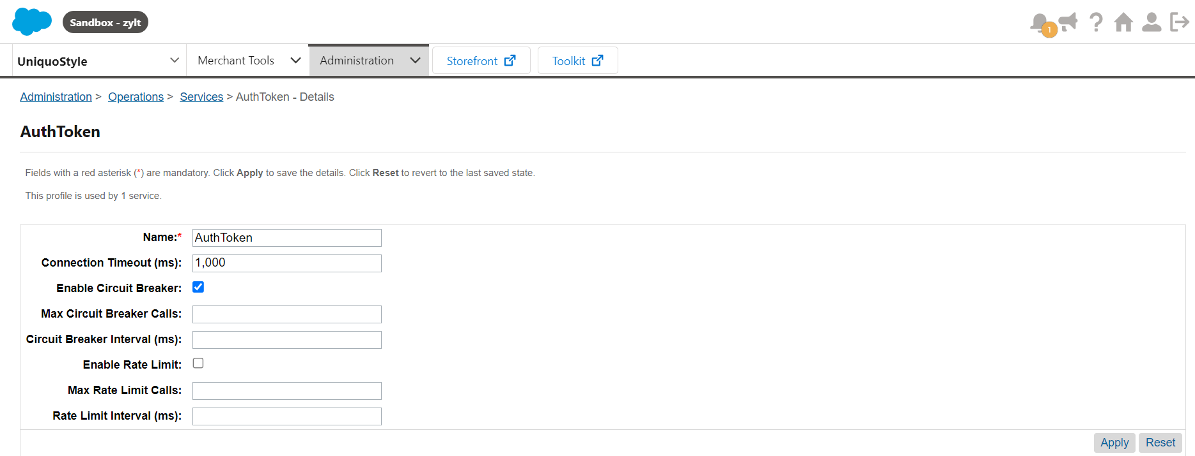

Credentials:

calling the url : https://zylt-001.dx.commercecloud.salesforce.com/dw/oauth2/access_token.

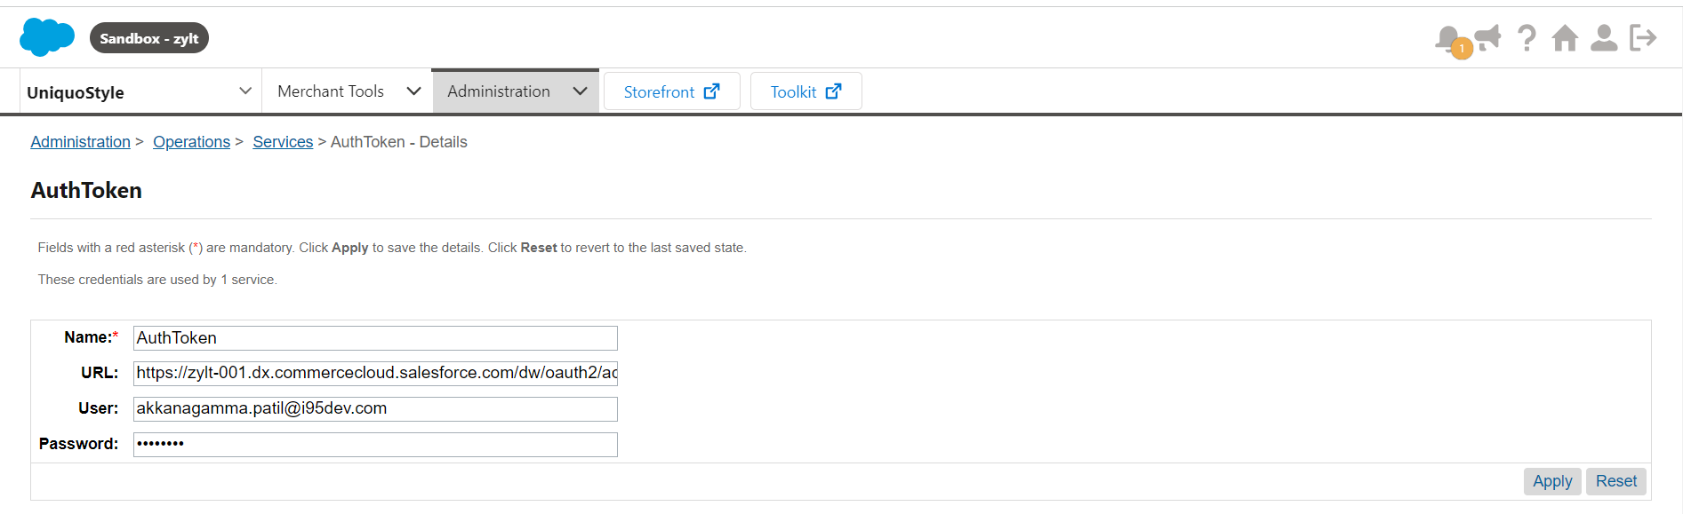

In CouponCode script file using one of the function called authToken() reading the value of access Token.

Passing the parameter clientId for this function, If the service is valid then it will return the access-token value or else error message.

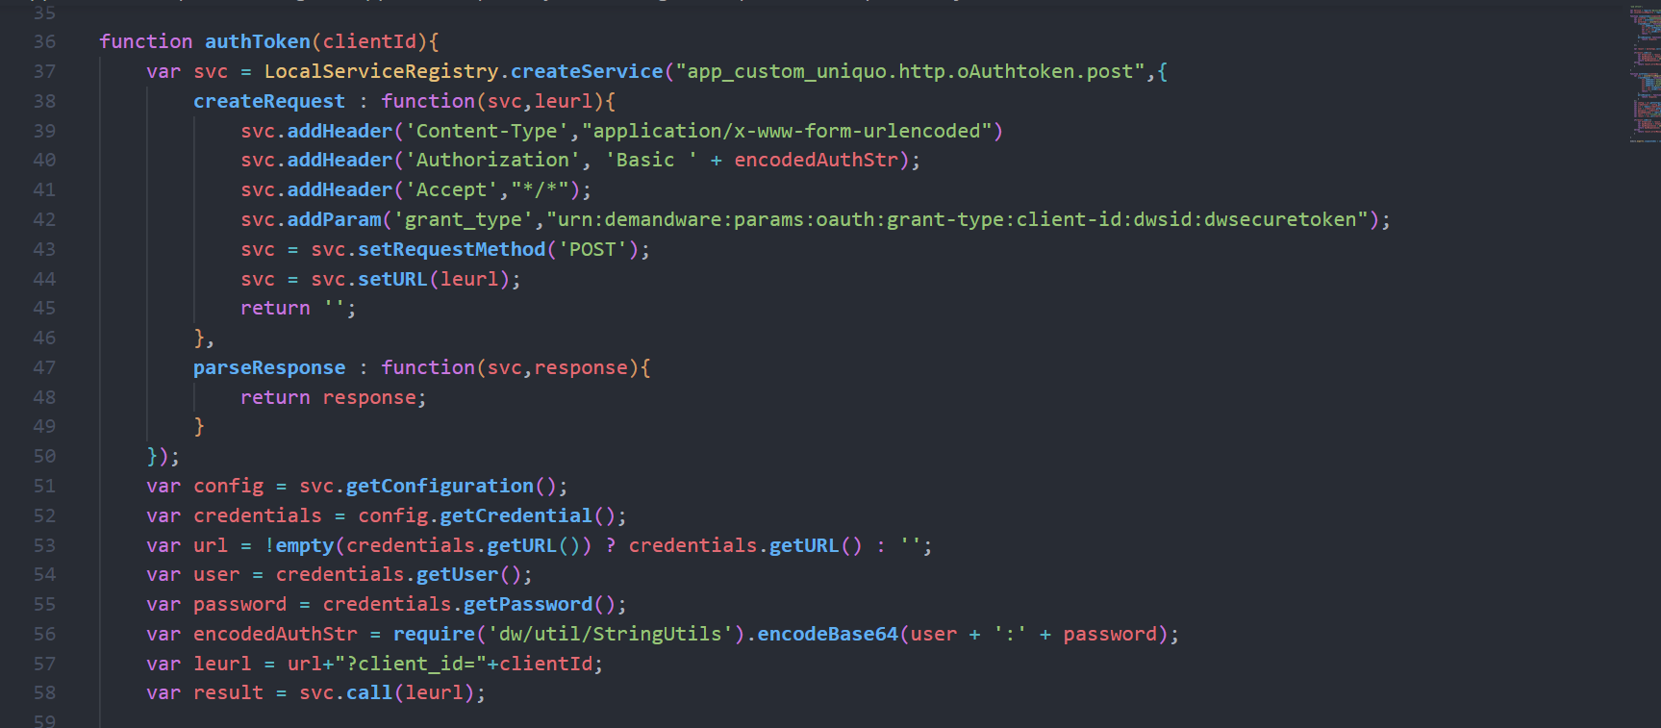

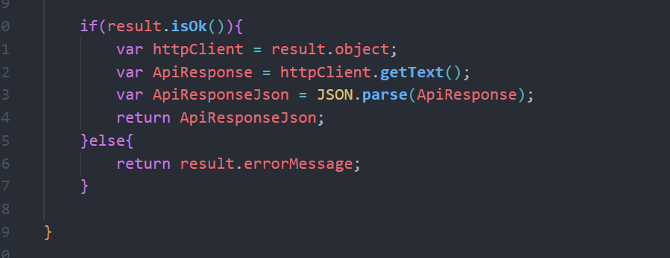

This access token is returned back to the function couponCodes to read the coupon code values.

From this function only the authToken() is called, and the access-token value is collected.

### Coupon Code Service

To get the coupon code new service is created.

Service:

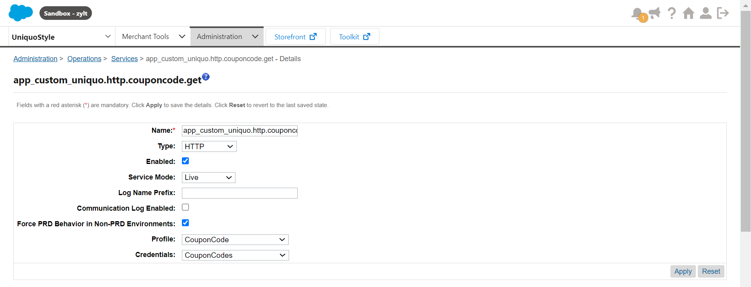

Profile:

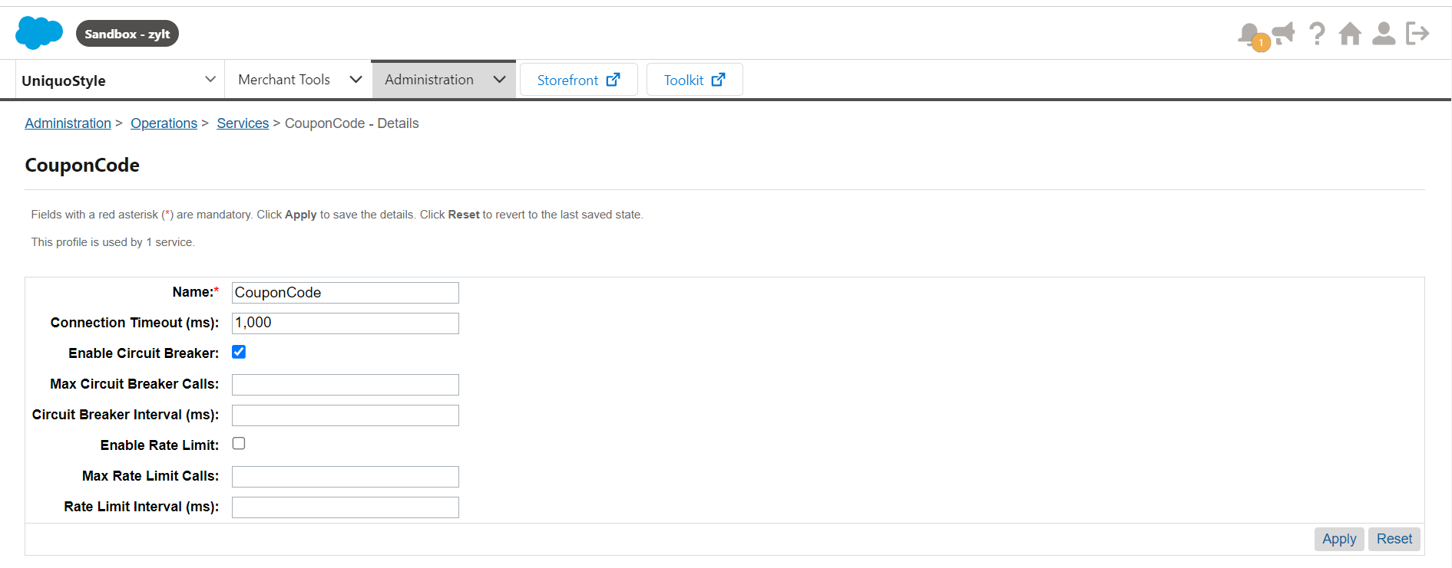

Credentials:

Url : https://zylt-001.dx.commercecloud.salesforce.com/s/-dw/data/v24_1/sites/UniquoStyle/coupons

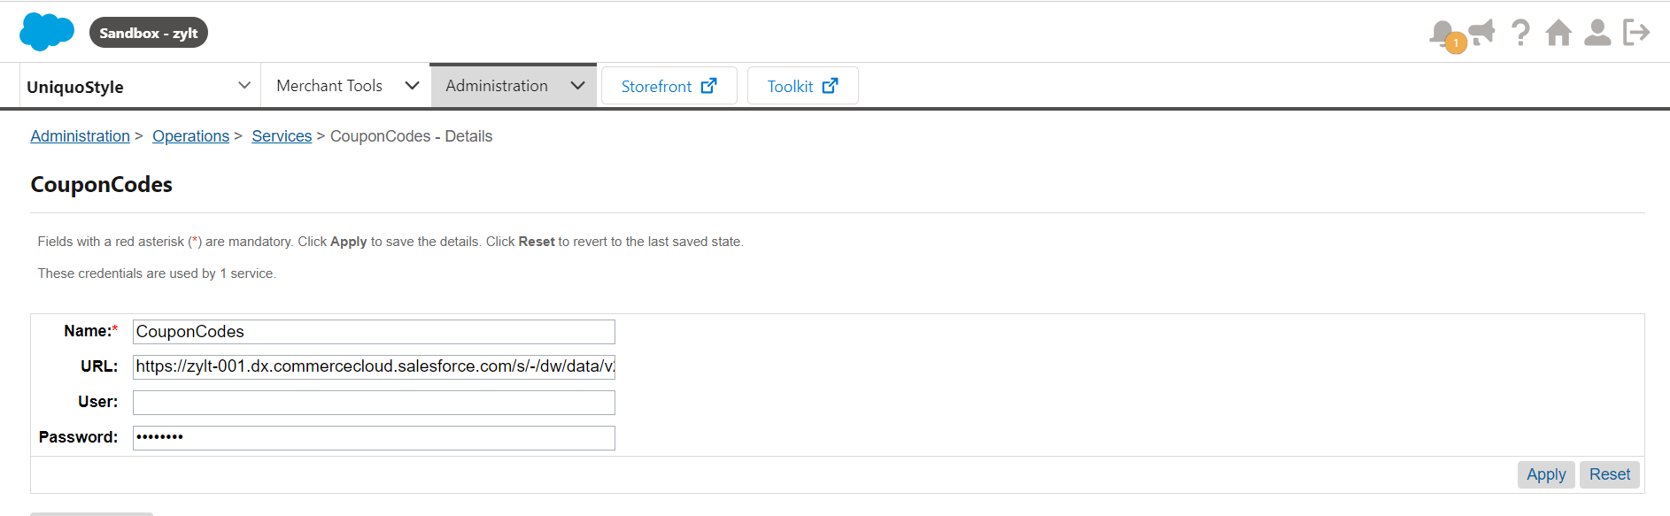

This is service is called in the couponCode() function.

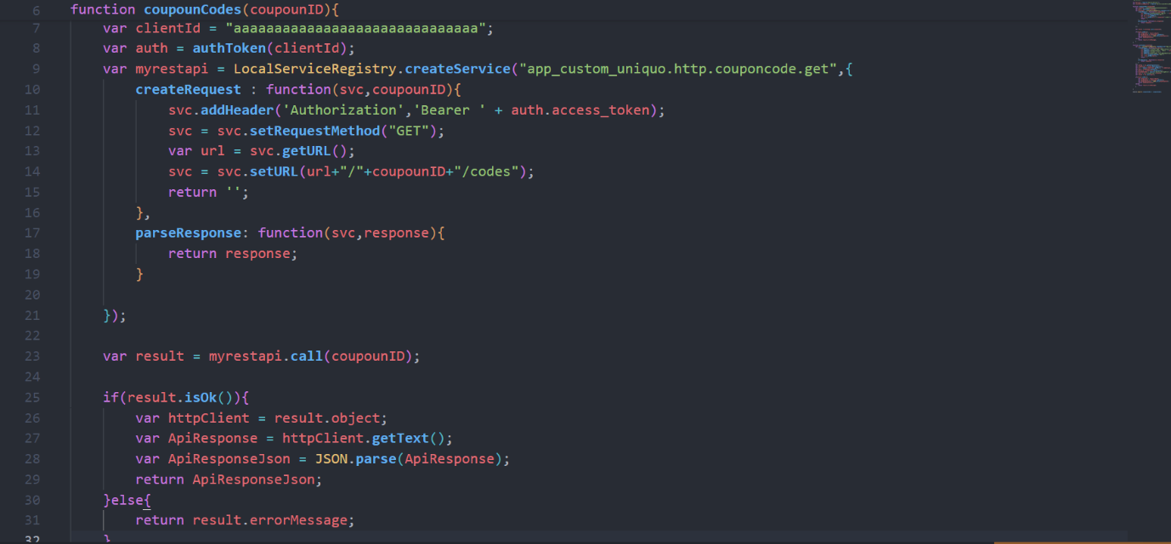

For this url we are setting the coupon Id to get the codes related to coupon.

If the coupon Id is valid one and that coupon is available means it will return the codes or else returns the error messages.

Not only the coupon codes all the details of the coupon is read in the coupon script file.

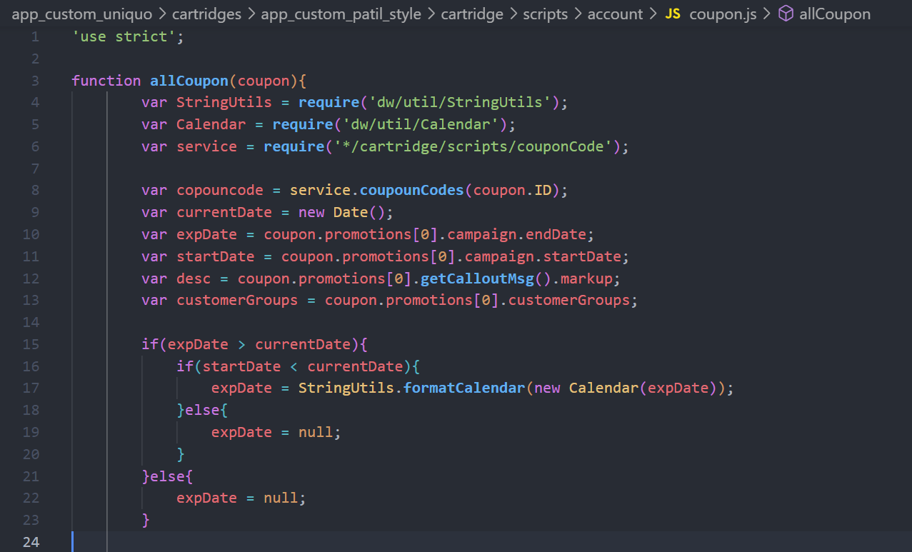

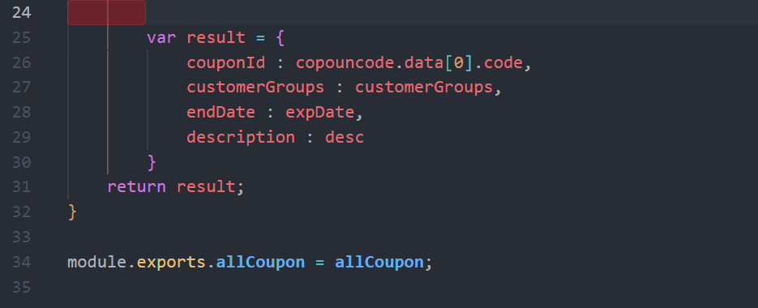

From this function the result object is returned to the controller to display the properties in the coupon page.

## Controller

In the controller first validating whether the customer is logged in or not. If the customer is logged in customer reading the customer first name and last name.

If not logged in user just returning the as ‘guest user’.

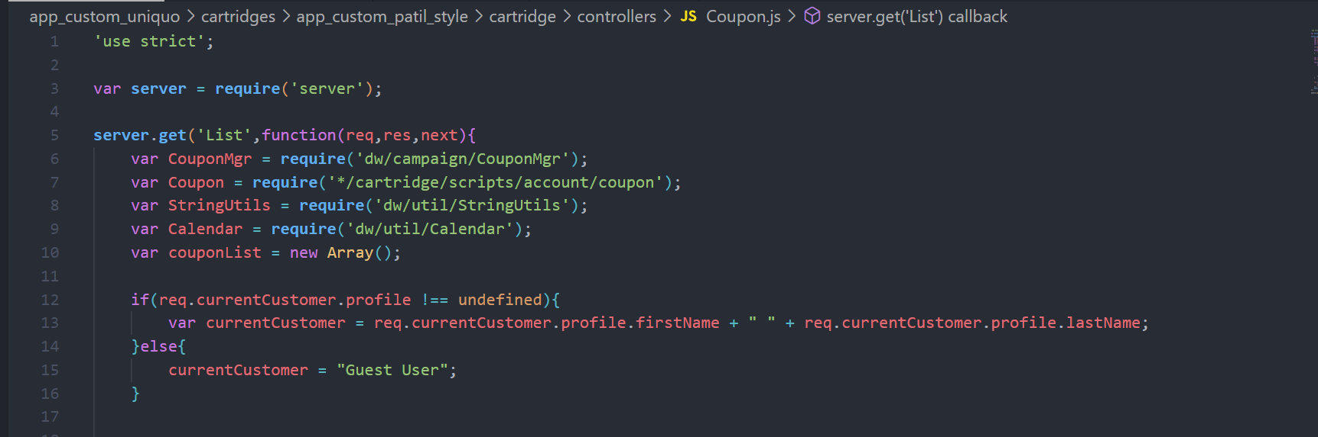

Iterating over the all coupons which are available in the BM and by calling the script file function allCoupon() by passing coupon object getting the result object.

Next based on the customer group whether the customer is applicable for that coupon or not is checking.

Using res.render() function displaying the coupon details by passing current customer and coupon List values as object.

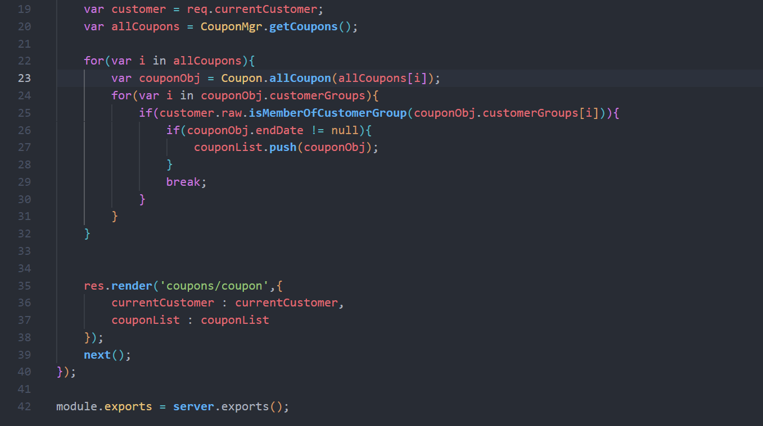

## ISML Template

To show the coupon page details we are using coupon.isml template.

In this file we are using decorator tag to add the header and footer for the page.

Using isscript tag adding the client side scss for the page.

First div will show the customer’s name if the customer is logged in or else as a guest user it will display.

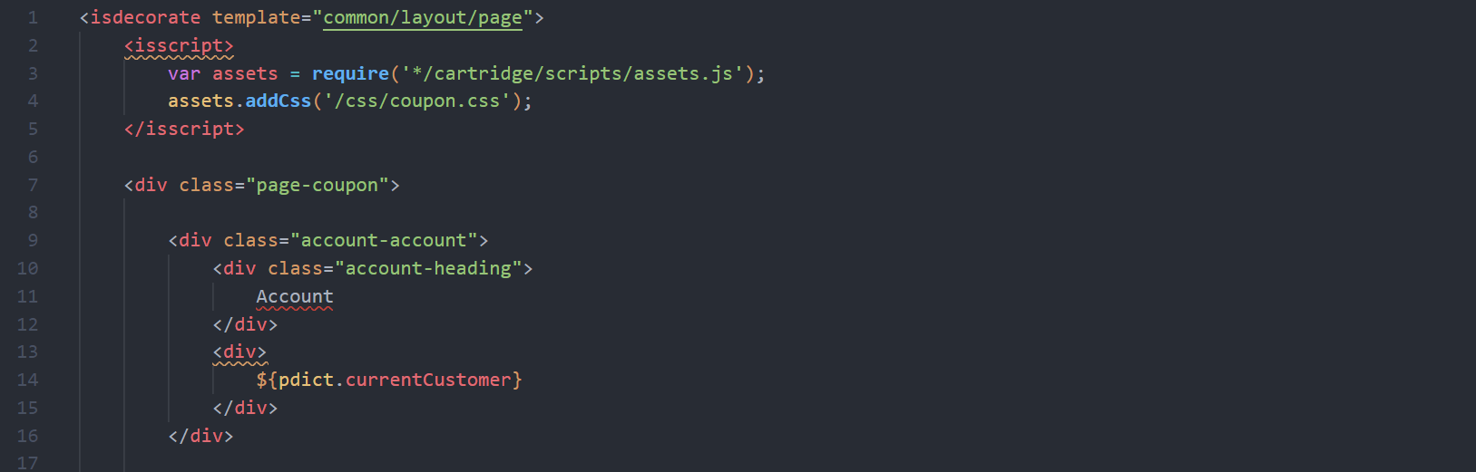

Next it will display all the coupon details based on the customer.

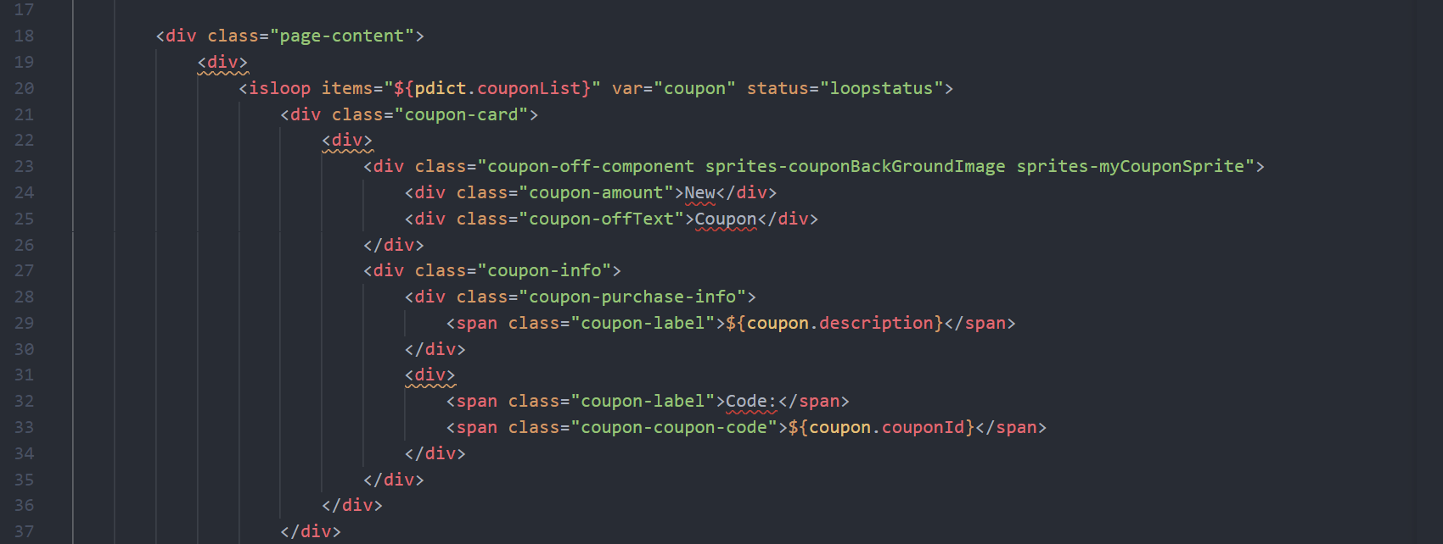\

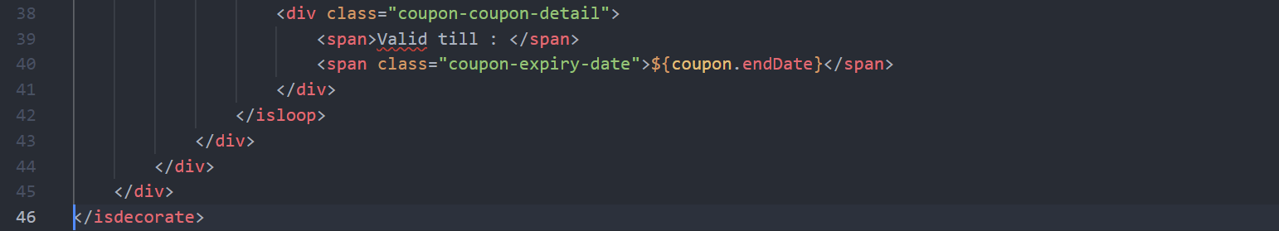

# Page Accessible

The customer can access the page by going to the profile and there is option as coupons to get the coupon page.

The below image is for the guest customer.

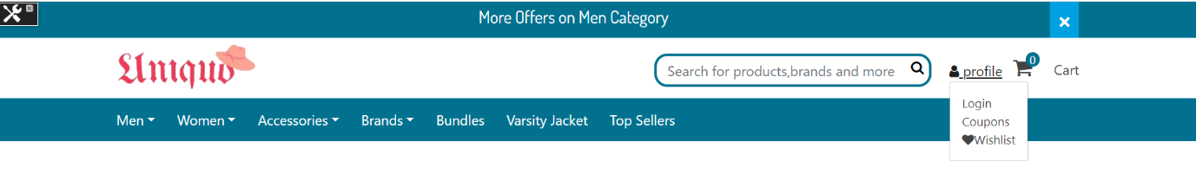

For the Logged In customer can see more data in profile and access the coupon page.

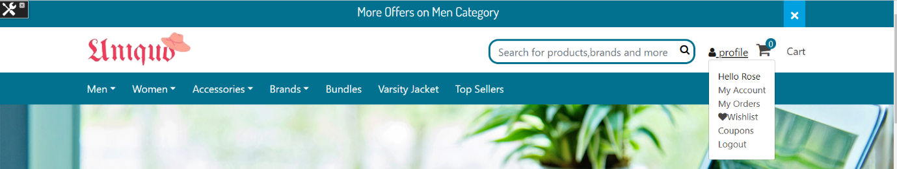

The code implementation for the above profile is:

Templates à default à account à header.isml

In the header.isml file the one more list value is added to get the link for the coupon page.

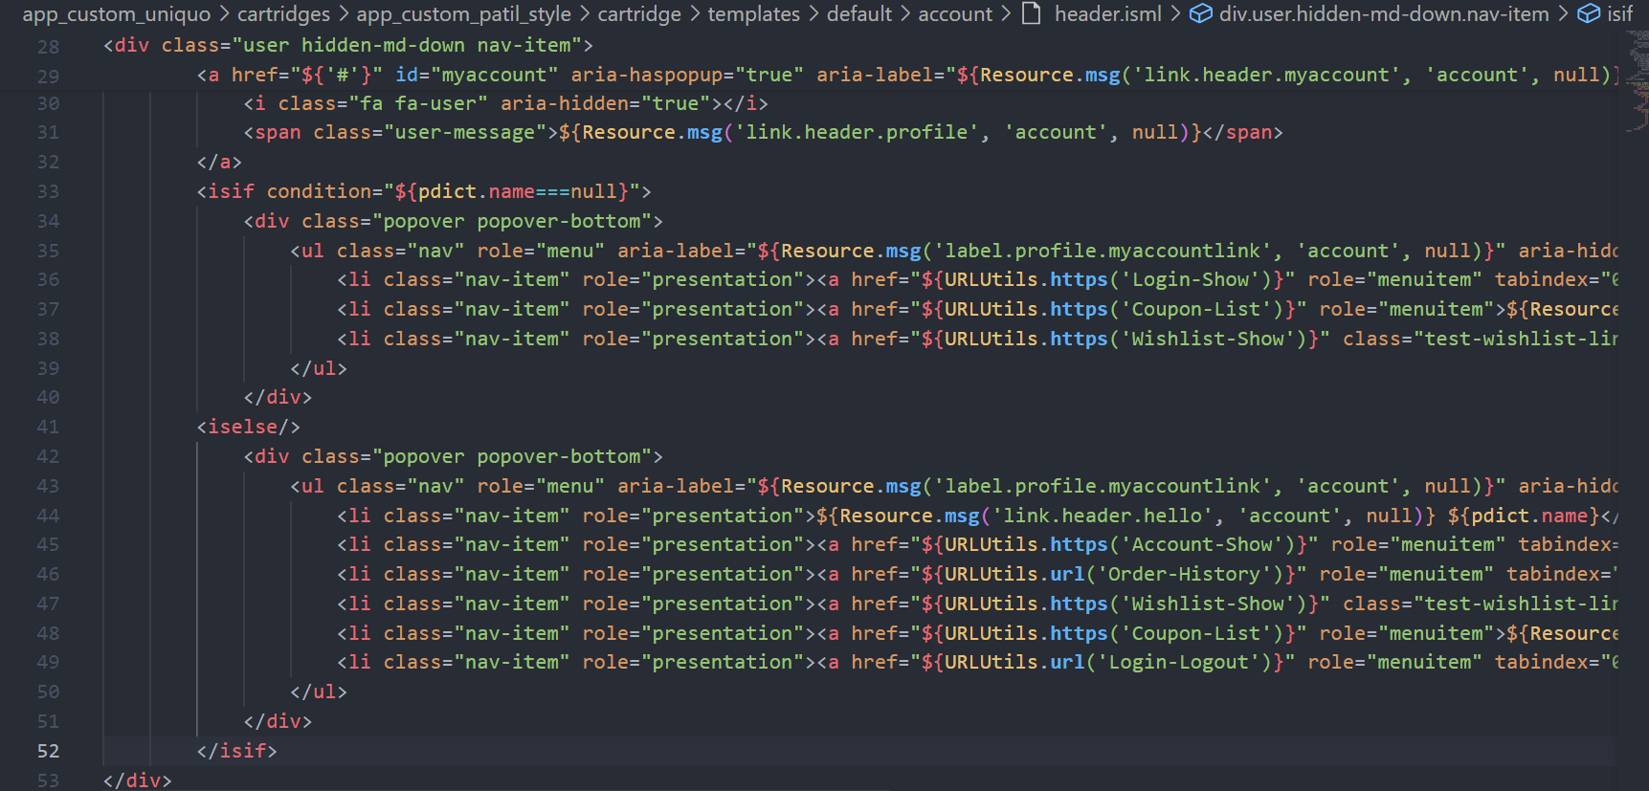

# Result

Now after adding all the code in the respective files, now the coupon details are going to display when the user clicks on the coupons option in the profile.

## Guest user

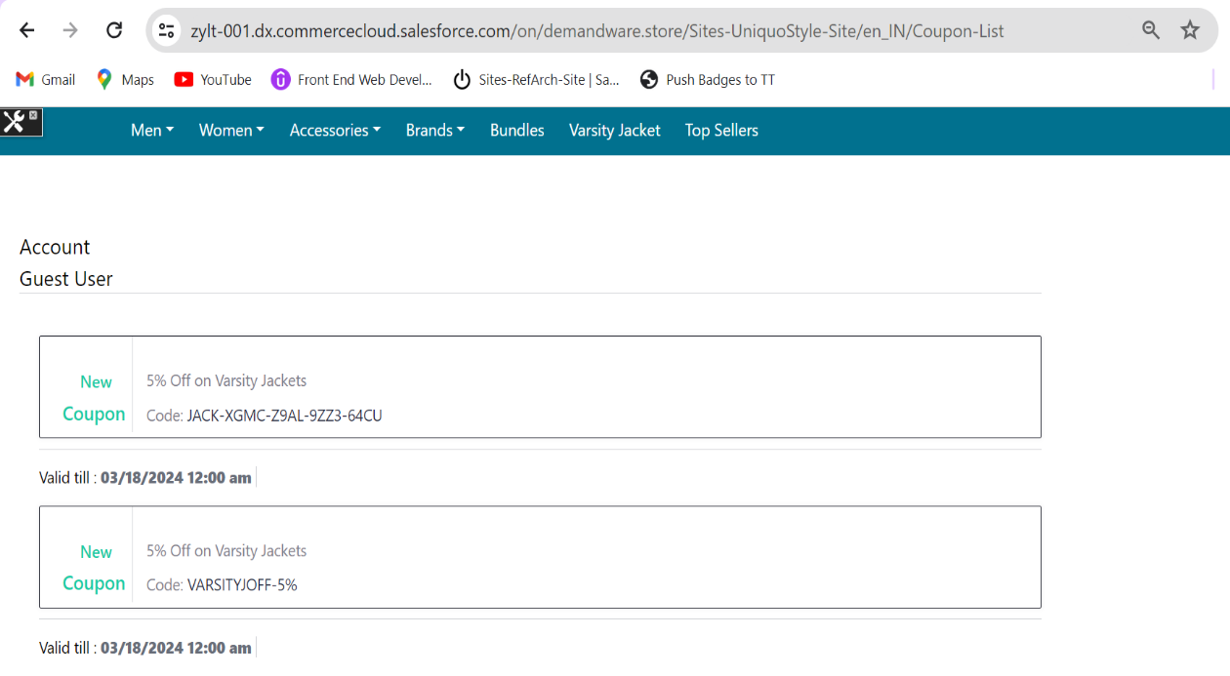

## Registered User

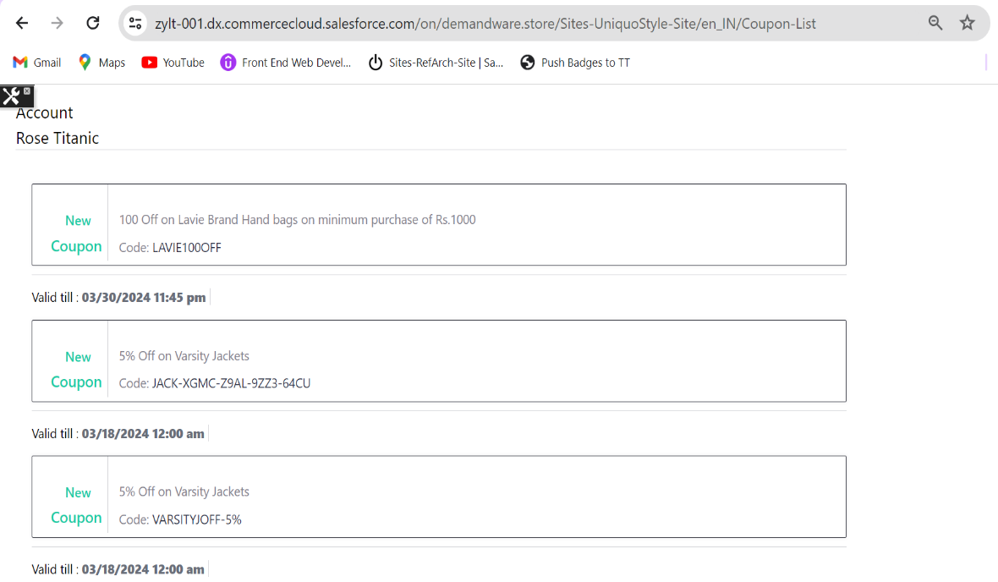

***Cash On Delivery Payment Method for Salesforce B2C Commerce***

Storefront Reference Architecture (SFRA)

1. Summary 43

2. Implementation 43

2.1 Payment Processor 43

2.2 Payment Method 44

2.3 Code implementation 45

2.3.1 Captcha generator 45

2.3.2 Calling the captcha generator function 46

2.3.3 Cash on delivery tab 47

2.3.4 Cash On Delivery Content 48

2.3.5 Hooks 50

2.3.5.1 Hooks.json file 51

2.3.5.2 cash_on_delivery 51

2.3.5.3 cash_on_delivery_processor 53

2.3.6 Models File 54

2.3.7 Payment Summary 55

2.3.8 Client Side Js 56

3.0 Result 56

3.1 COD Tab 56

3.2 COD Content 57

3.3 Error Messages 57

3.3.1 No Captcha Entered 57

3.3.2 Invalid Captcha 57

3.4 Summary 58

3.6 BM order 59

# Summary

Adding the cash on Delivery payment Method in the payment Section. The user either can choose Credit/Debit Card or Cash on Delivery payment Method to place the orders.

# Implementation

Before starting the code implementation need to add the payment method and payment processor in Business Manager.

## Payment Processor

First need to create payment processor for cash on delivery.

Go to the Business Manager.

Select Site à Merchant Tools à Ordering à Payment Processors à New.

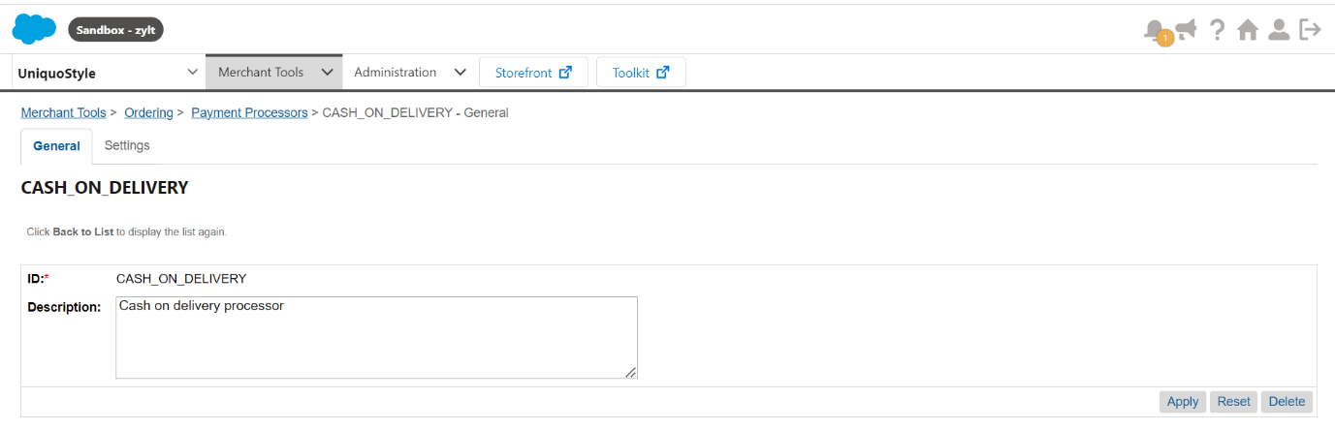

After creating the new payment processor, it will display as shown below.

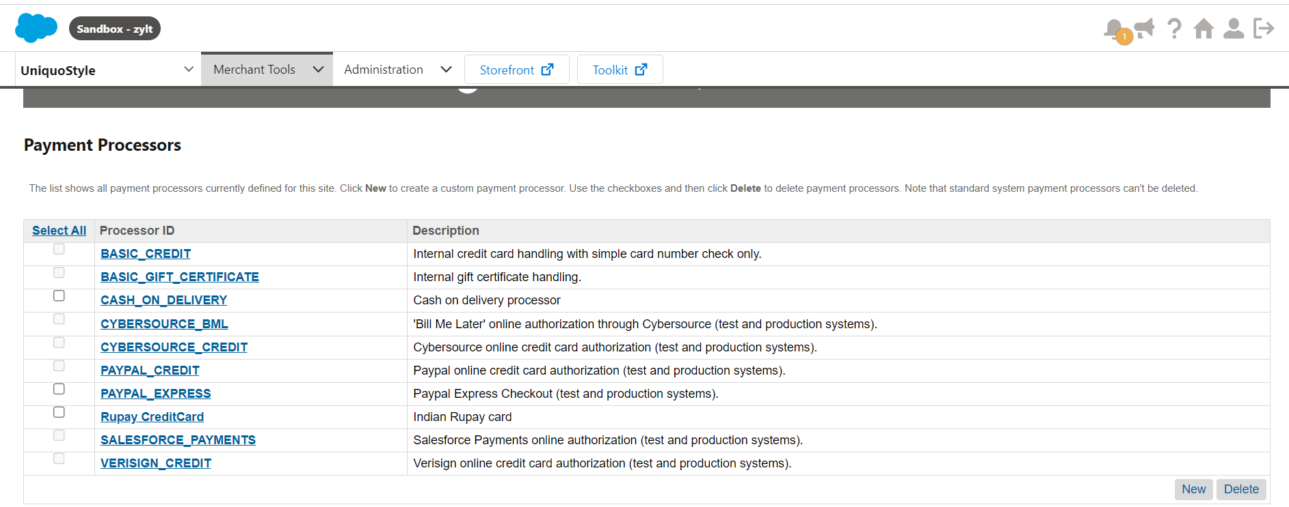

## Payment Method

After adding the payment processor now needs to create a new payment method.

To create new Payment Method.

Go to the Business Manager.

Select Site à Merchant Tools à Ordering à Payment Methods à New.

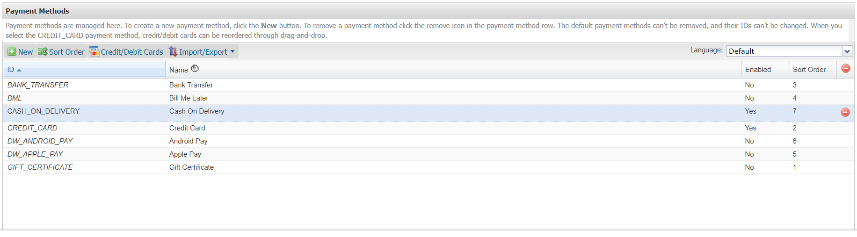

For that payment method need to assign the payment processor which is created initially.

And in the payment methods the enabled option is set to be true to provide the cash on delivery option for the users.

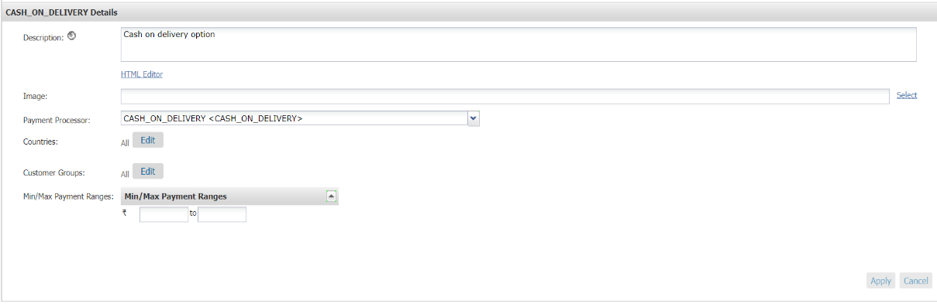

The BM configuration is complemented now need to do the code configuration in visual studio to display the option for the user and use it.

## Code implementation

For the cash on delivery payment option adding the reCAPTCHA where the random number is displayed and the user needs to enter the same value as shown.

### Captcha generator

Using the randomCaptcha.js script file creating a new random value to display in the cash on delivery option method.

The captcha is the combination of the capital letters, small letters and numbers of length 6.

From the randomValue() function the captcha is returned which is in the length of 6.

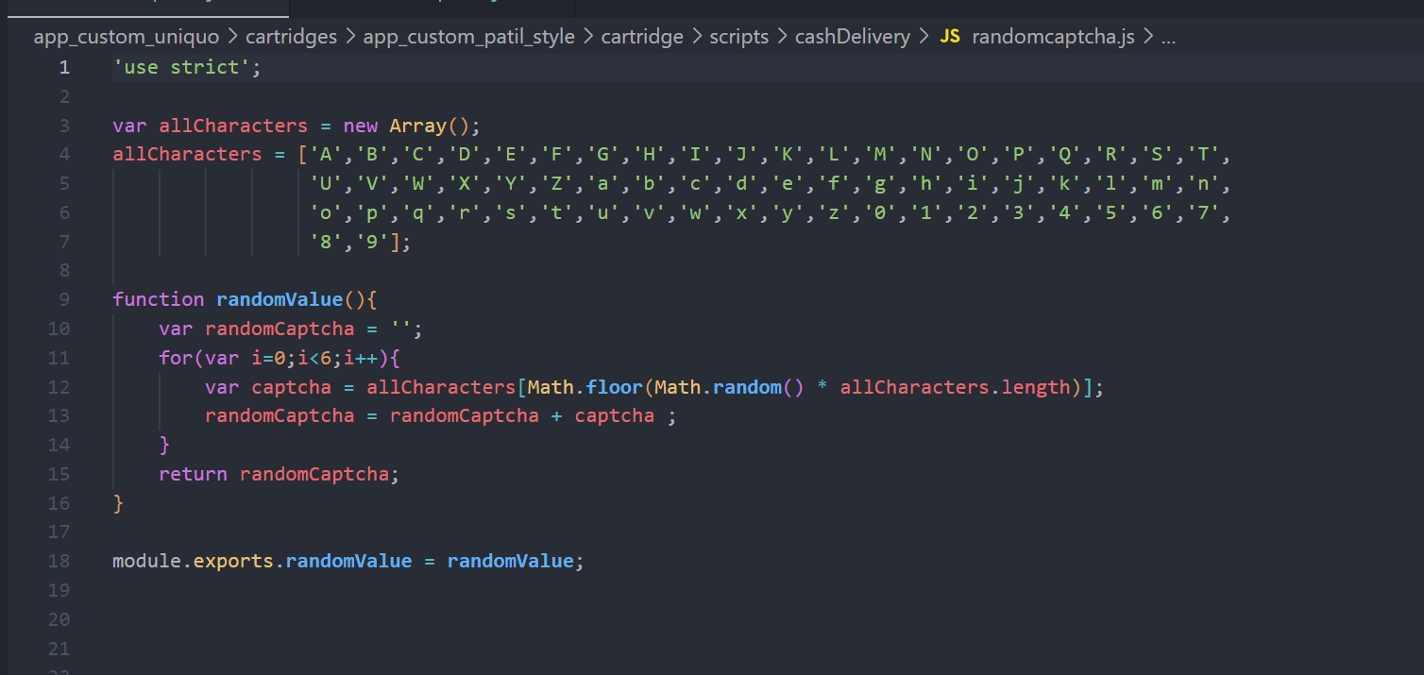

### Calling the captcha generator function

Checkout.js is the controller which helps to display the payment methods, so the randomCaptcha.js script file is required in this controller.

And calling the randomValue() to get the captcha generated value

In the Begin route requiring the script file.

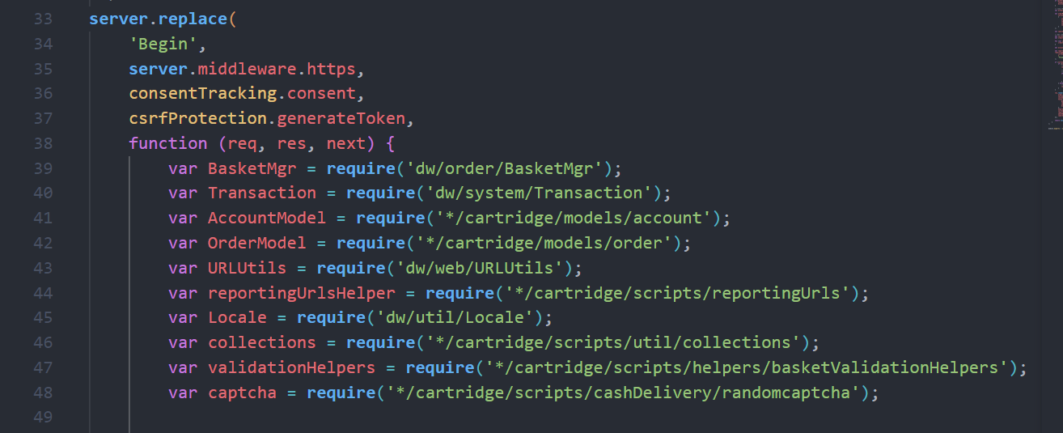

And then calling the randomValue() function.

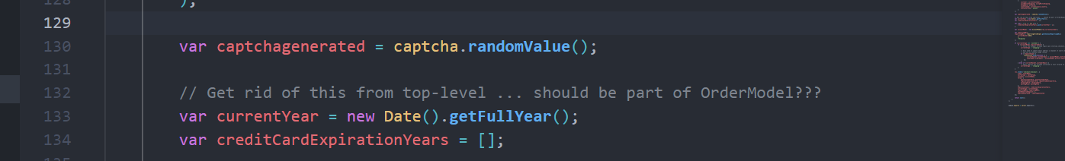

The collected captcha value is passed to the checkout.isml

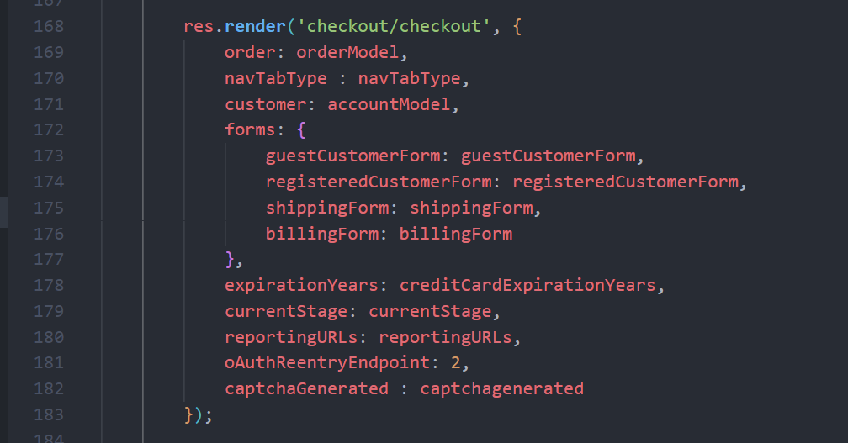

In this way the captcha value is passed to the payment tab.

### Cash on delivery tab

To show the cash on delivery tab beside the credit/debit card need to follow as shown below.

This completely related to the isml templates to show the COD tab.

To show the tab for COD then changes should be done in the paymentOptionsTabs.siml

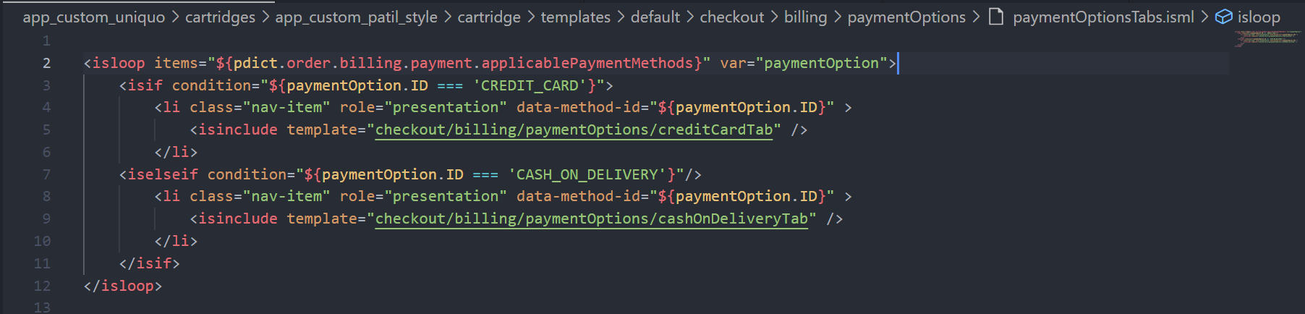

If paymentOption Id is cash_on_delivery then the new tab should be displayed so for that within paymentOptions folder adding the new isml file called cashOnDeliveryTab.

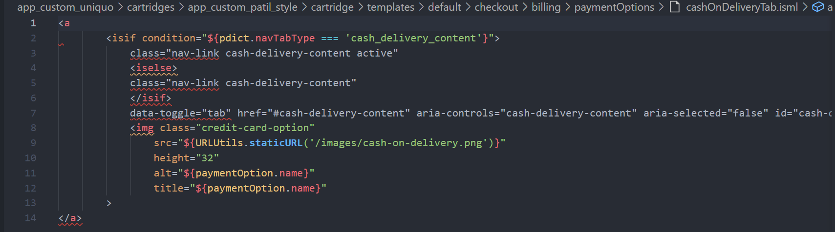

In the tab option we are getting the COD image and whenever we hover the mouse on that tab it shows cash on delivery.

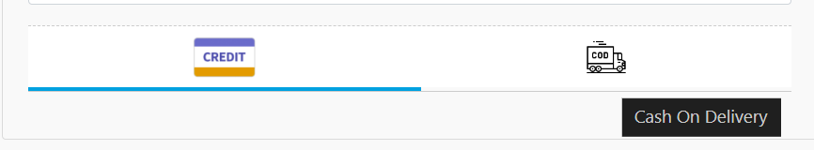

### Cash On Delivery Content

Now it’s time to show the content for COD tab. Whenever the tab is selected then the content needs to be displayed.

For that the changes to be done in the paymentOptionsContent.isml file

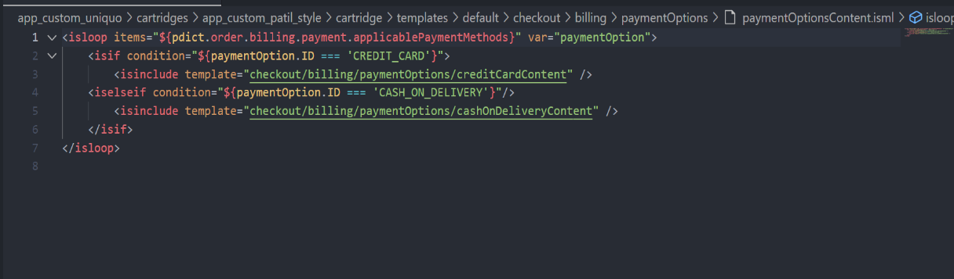

If paymentOption Id is cash_on_delivery then the new content should be displayed so for that within paymentOptions folder adding the new isml file called cashOnDeliveryContent.

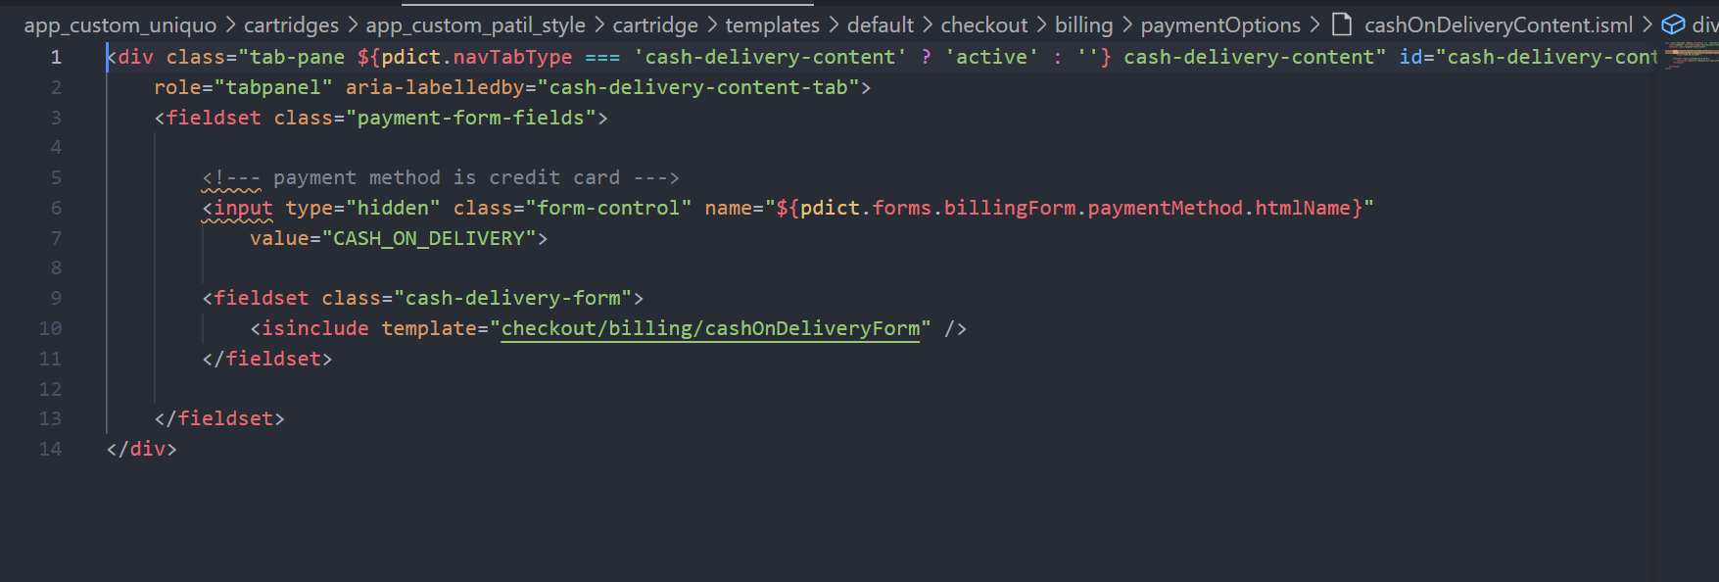

In this template using isinclude tag a new file is included for showing the captcha and one input field to enter the same value as captcha.

For that adding the cashOnDeliveryForm in the billing folder.

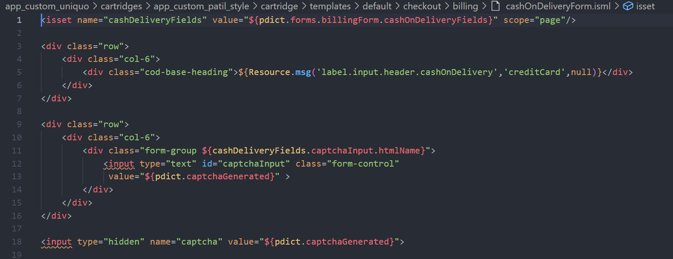

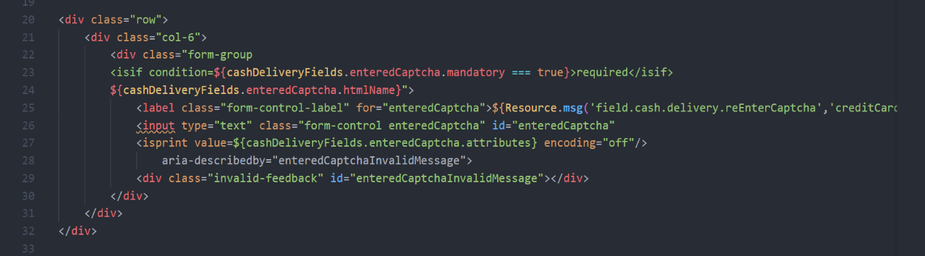

The xml file for the cashOnDelivery form is shown below.

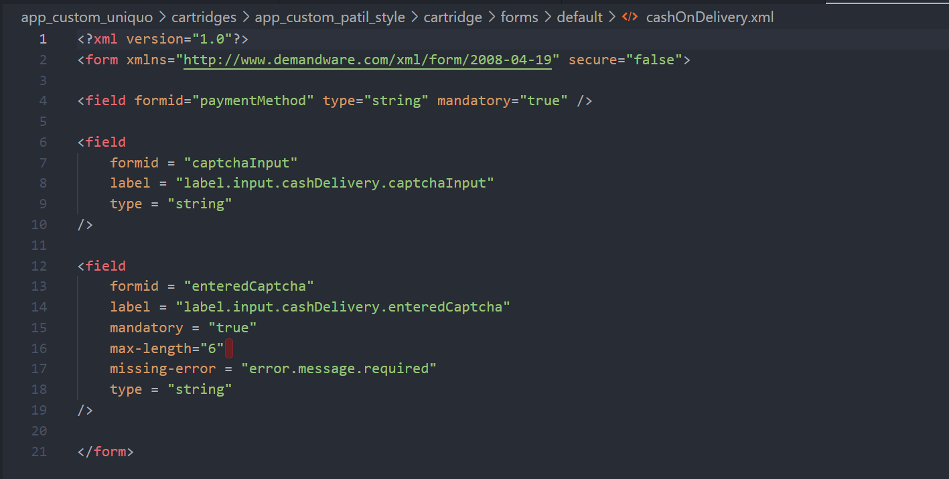

After adding the content, the COD content looks as shown below. Whenever the COD tab is active then the content will be displayed.

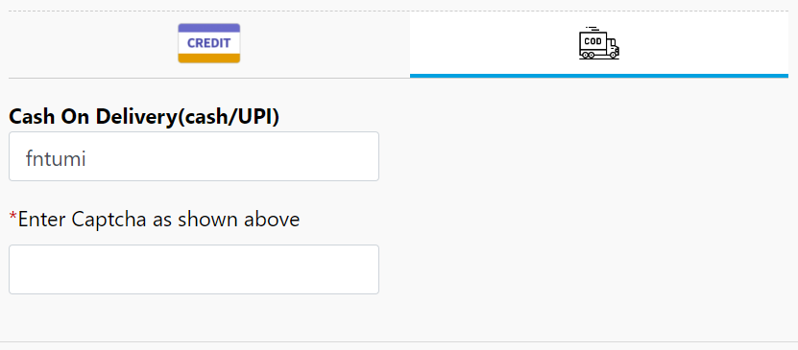

If the user clicks on the place order without entering the captcha means it will show the field error as shown below.

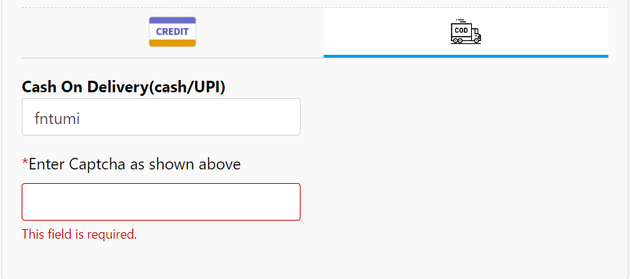

The random value will be displayed and the whatever the user enters the value that also read when user clicks on the place Order.

### Hooks

When the user clicks on the place order button, the checkoutServices-submitpayment route is going to execute.

So, when the user uses COD option for payment method this controller-route is going to collect the values.

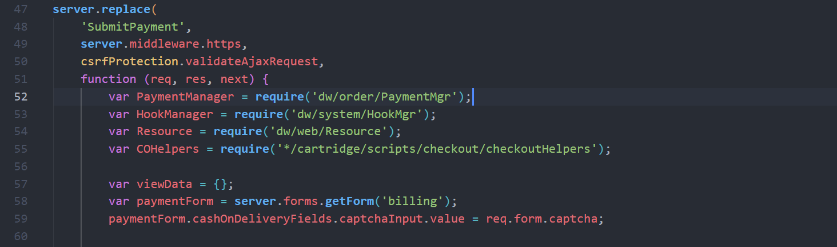

Within the paymentForm the data is going to be collected.

To check the COD details is valid or not the script files are used.

Mainly hooks are going to be used.

So, using the hookMgr classes the particular hooks file is going to be called.

#### Hooks. Json file

The hook file defines a uniquely named extension point and a script to run. You can implement hook scripts as a CommonJS module. This approach ensures that the script identifier is a module identifier. The value of this identifier can be a relative path or any other valid module identifier.

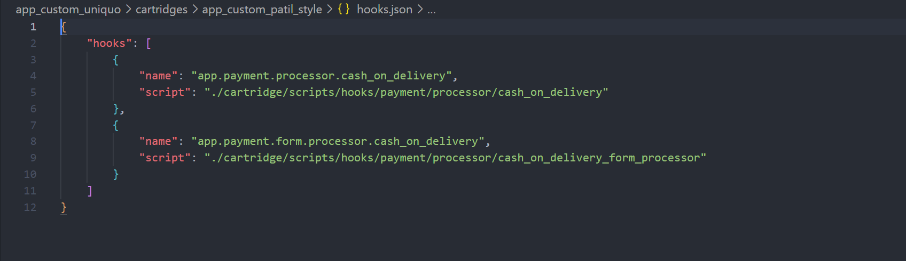

The extension points and script file path are added for the COD. Using the extension point the files are called in controller.

#### cash_on_delivery

The first extension point added in the script file which points the file cash_on_delivery from processor folder.

This file contains mainly three functions createToken, Handle and Authorize.

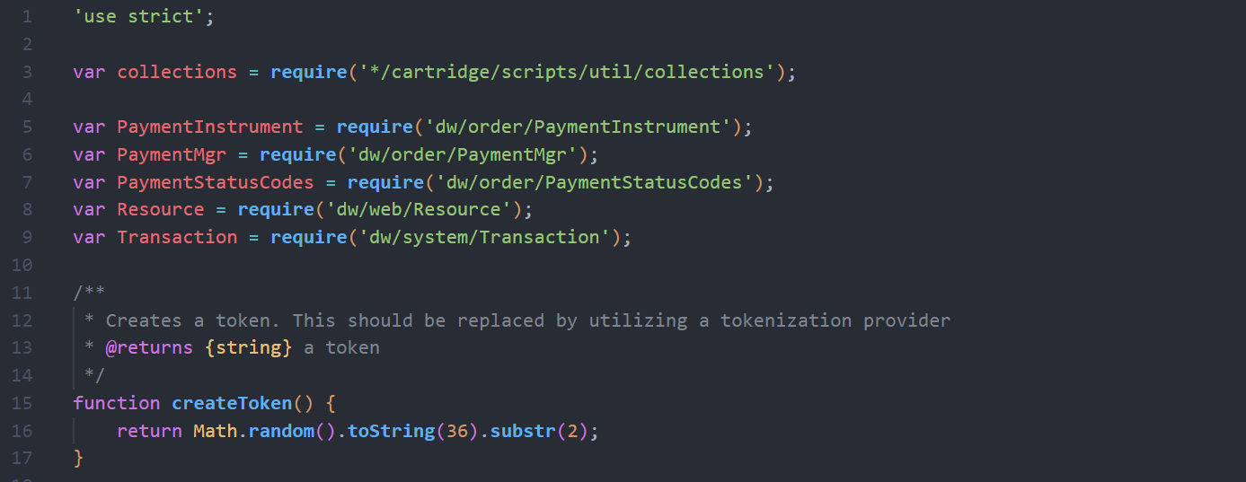

Next Handle() function helps to validate all the fields entered in the payment form. In this method only the user entered value is valid or not checking. If its not same as shown the error will be returned as shown below.

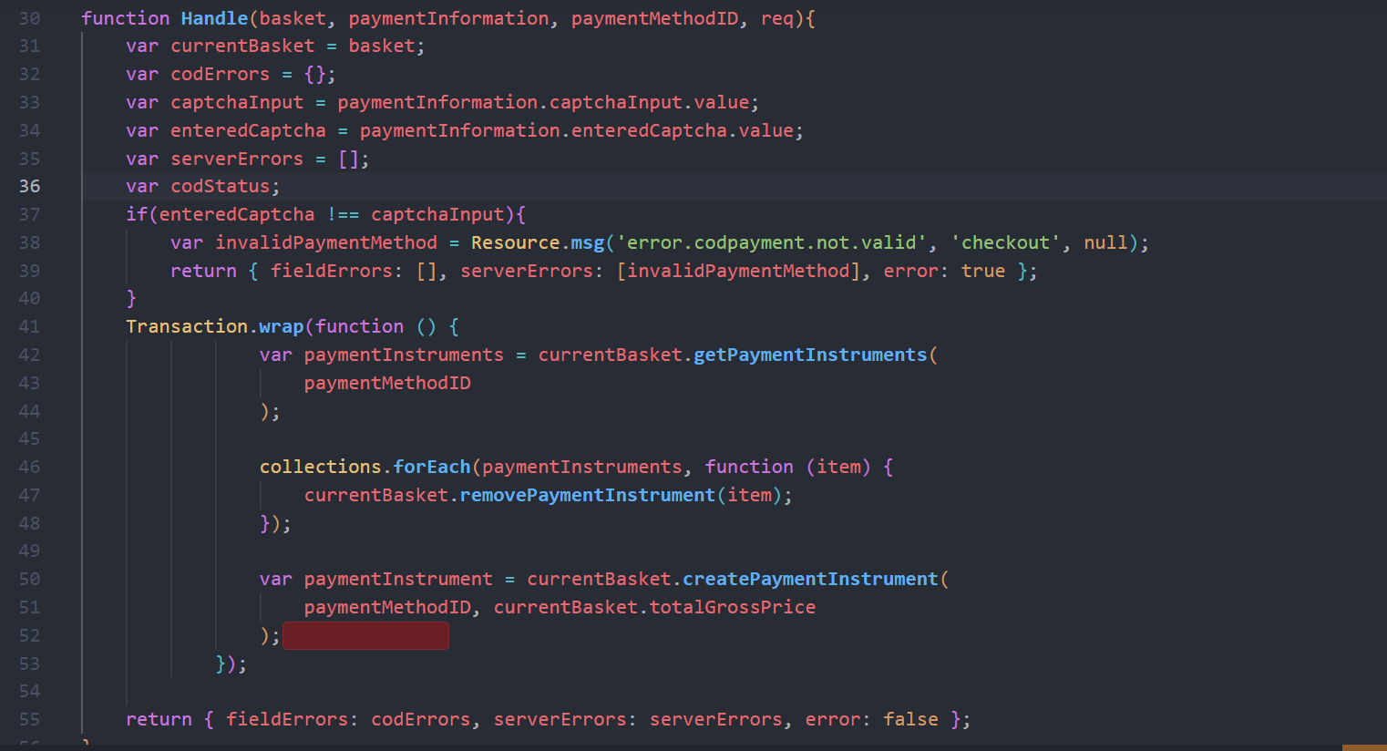

Next in Authorize () function, it authorises a payment method and payment processor value is assigned to the paymentInstrument and setting the order number as transaction Id.

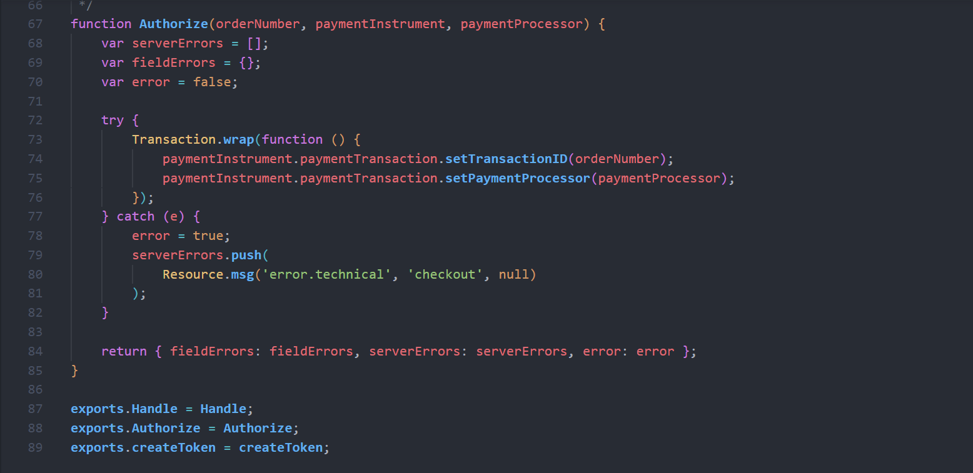

#### cash_on_delivery_processor

In this form mainly validates the information from the billing Form is provided.

There is one function called processFrom().

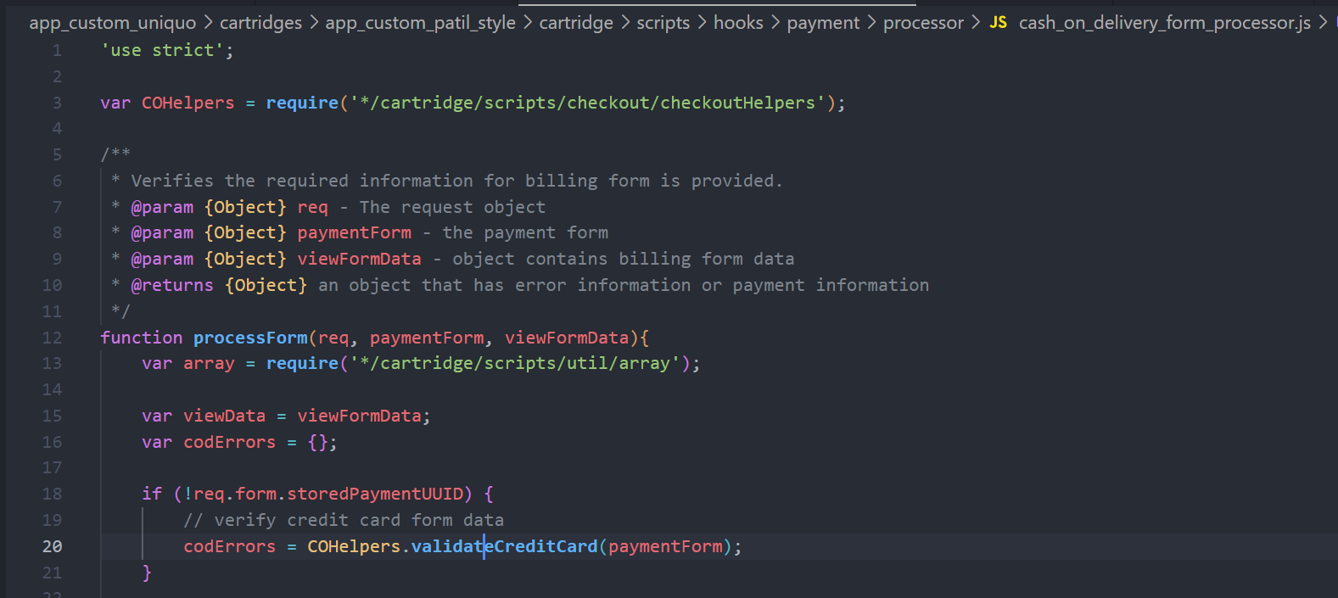

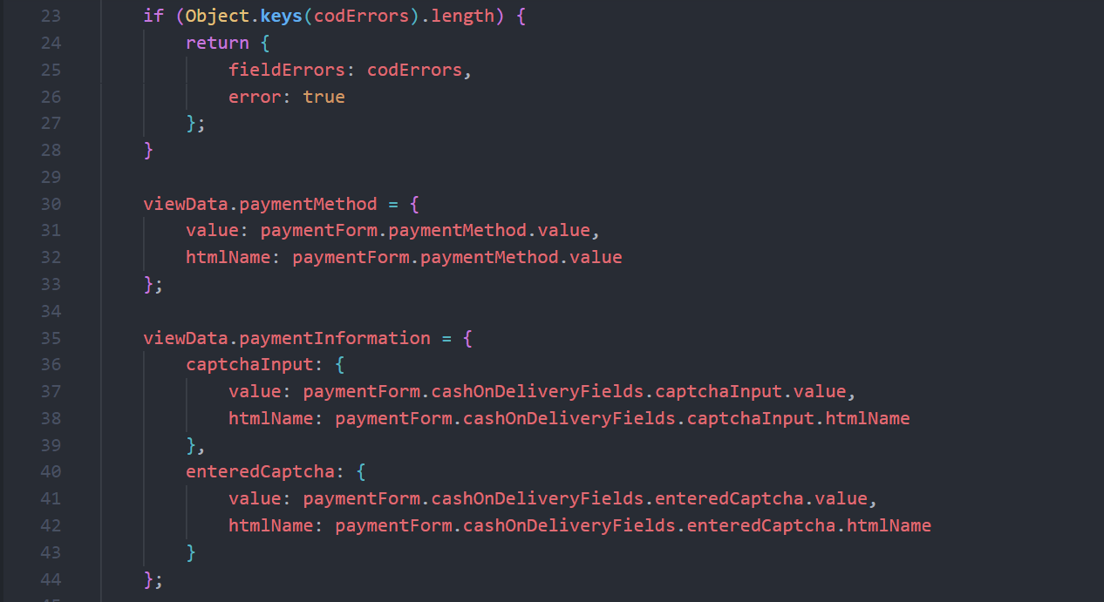

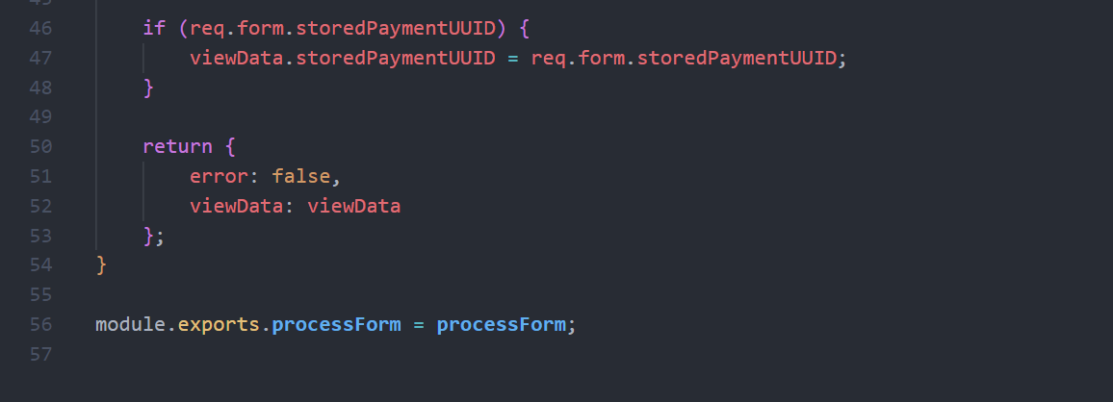

### Models File

In the payment.js file of model folder contains the getSelectedPaymentInstrument() returns the array object based on the selected payment method, the object is returning.

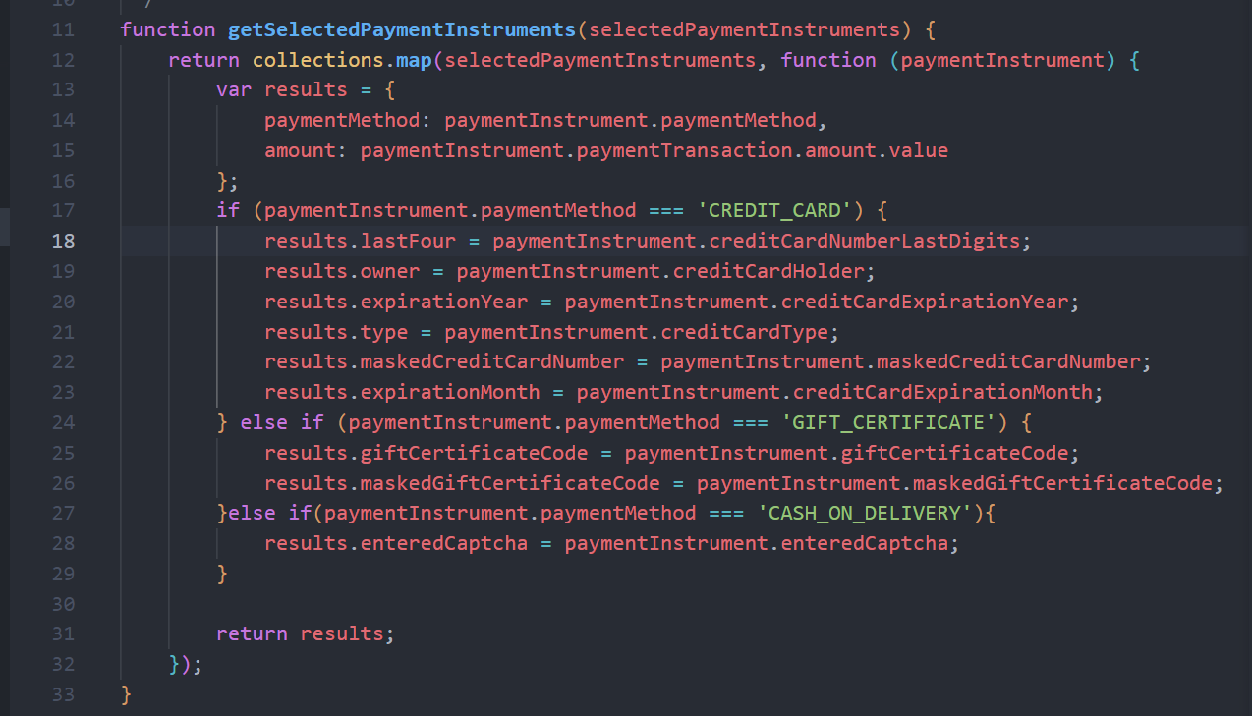

### Payment Summary

After user clicking on the place order, the summary of customer information, shipping and payment is displayed.

Now the summary of COD payment to be added in respective isml files.

In the paymentOptionsSummary.isml need to add the CODSummary using isinclude tag.

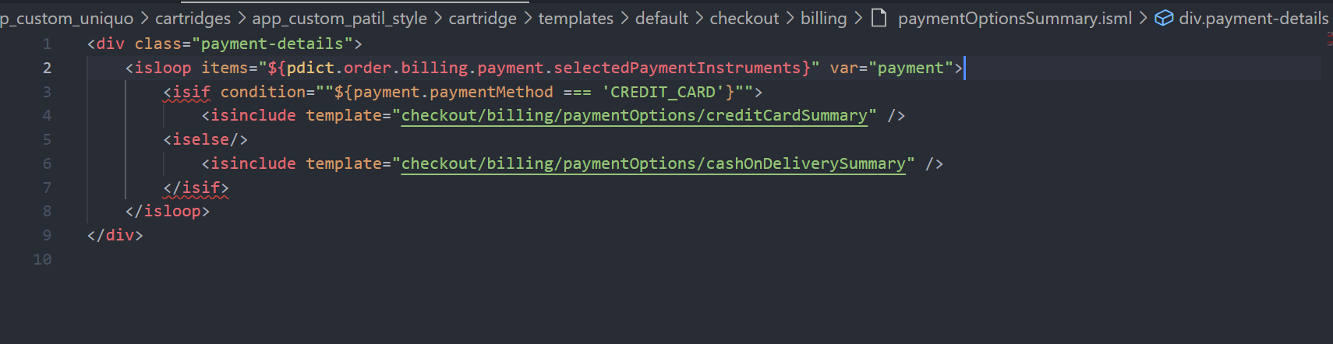

Now the summary what we want to show for the Cash On delivery payment method needs to be added in the CashOnDeliverySummary.isml

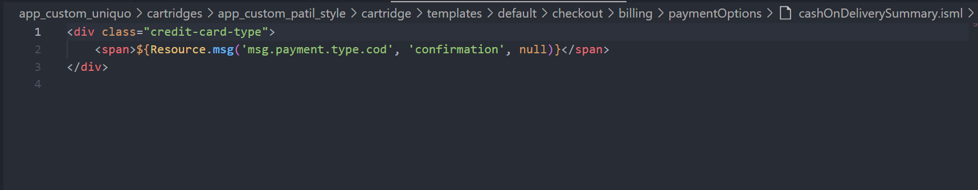

### Client Side Js

When the user clicks on the Place Order button the ajax is executing means without refreshing the whole page just the content is going to be updated i.e., the summary is going to be updated.

For Selected payment method only the payment summary will be updated for that

Client folder à js à checkout à billing

In the billing file the updatePaymentInformation() method needs to be updated.

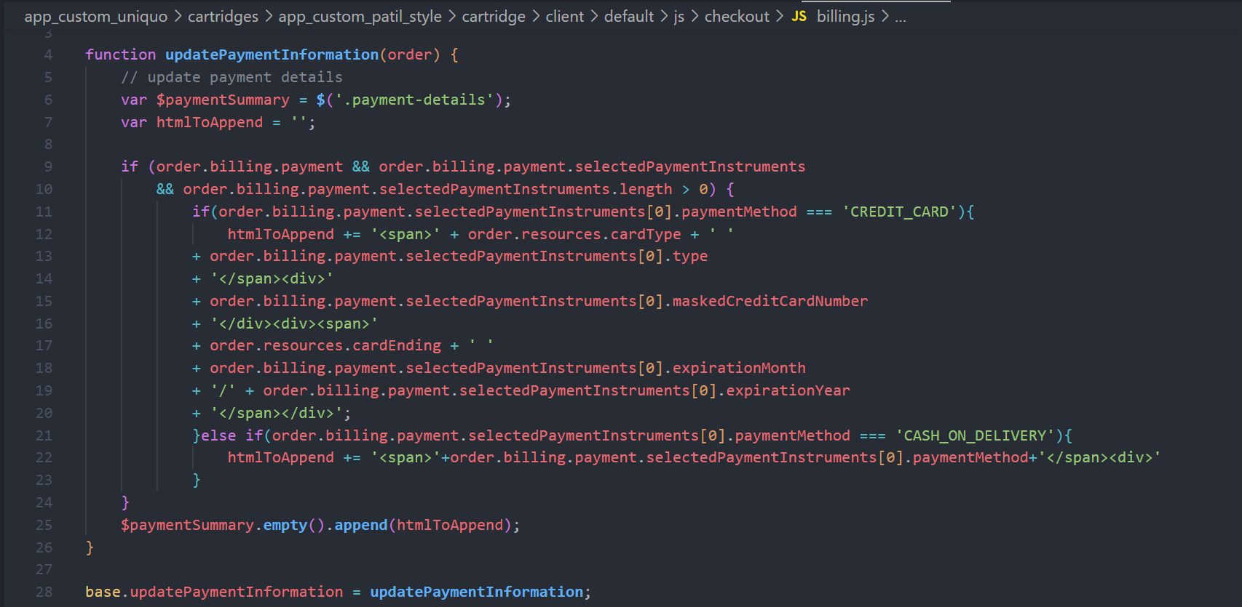

By including this condition, the information of COD will be updated.

# Result

Now After Implementing all the code, the results are displayed as shown below.

## 3.1 COD Tab



## 3.2 COD Content



## 3.3 Error Messages

### 3.3.1 No Captcha Entered

If the user clicks on the place order button without filling the captcha field means it will return the field error messages.



### 3.3.2 Invalid Captcha

If the captcha entered by the user is not matching as shown means the error message will be displayed as shown below.

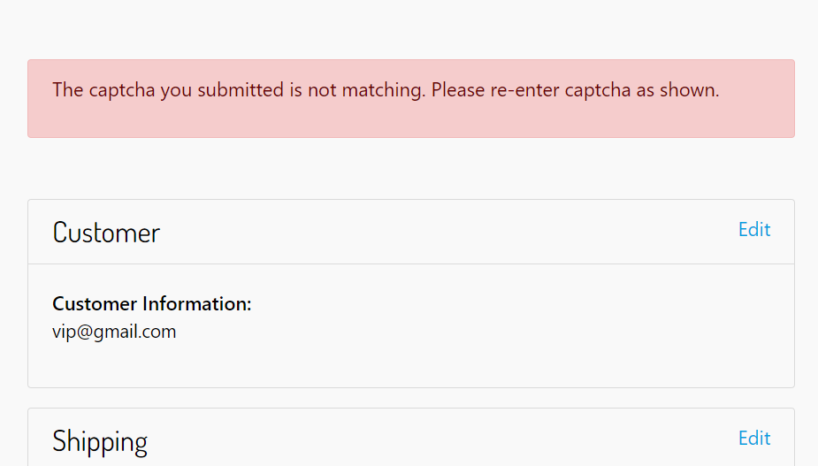

## 3.4 Summary

When the user clicks on place order the ajax is executed and details will be displayed as shown in below format.

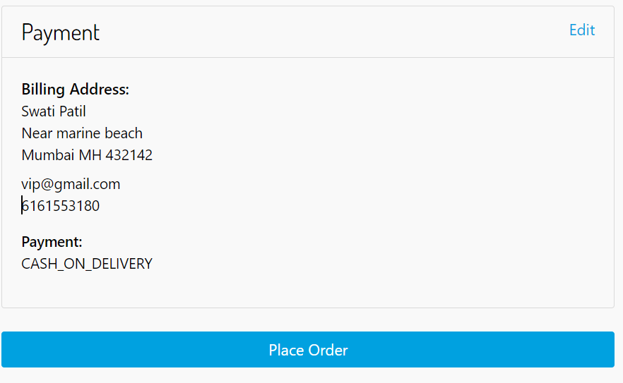

After once click on the place order the order is placed successfully and the below format the receipt is displayed.

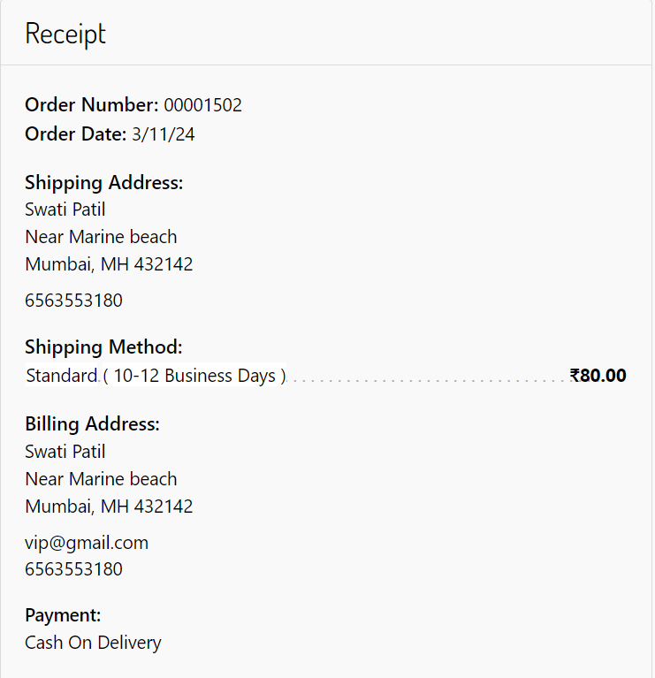

## BM order

Now In the BM Order details also the data is updated as shown below.

The payment Information is updated.

